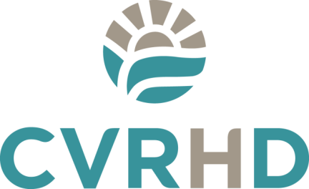
News Release

FOR IMMEDIATE RELEASE

October 29, 2013

Cowichan Valley Regional Hospital District seeks Real Estate Consultant for Potential New Hospital Site

Duncan, BC –The Cowichan Valley Regional Hospital District (CVRHD) today issued a Request for Proposals (RFP) seeking real estate expertise to identify properties that would fit into long term plans for the eventual replacement of Cowichan District Hospital.

Acquiring a suitable site for a new hospital is one step in the planning process which remains in the very early stages. A new hospital for the Cowichan Valley would require regional and provincial government approval. At this time no approvals or funding are in place.

“Recognizing the need to replace the Cowichan District Hospital, the CVRHD approached Island Health seeking its support to conduct a land search,” said Rob Hutchins, CVRHD Chair. “The CVRHD wants to do its part to ensure that the right piece of property is available should a hospital project be approved in the future.”

The acquisition of land does not guarantee provincial funding and approval for a new hospital. Should the long-term strategy for a new hospital eventually be approved and funded, the land acquired by the CVRHD would be part of its 40% contribution to the cost of a new hospital.

Members of the public will be invited to provide feedback on the site selection criteria that will be used in determining a location for a potential new hospital through a public process hosted by the Cowichan Communities Health Network. More information on this process will be announced in the coming weeks.

“Regional Hospital Districts are key funding partners for capital projects and we welcome the CVRHD’s interest in supporting the delivery of health care services for Cowichan Valley citizens,” said Don Hubbard, Island Health Board Chair.

The Request for Proposals document is posted on the BC Bid website, www.bcbid.ca. The deadline for submissions is Friday, November 22, 2013.

An Expression of Interest (EOI) process will take place later this year inviting landowners to submit properties to be considered as potential sites for a potential future new hospital.

-30-

For more information contact:
Rob Hutchins, Board Chair, CVRHD
Tel: 250-210-1471
Email: rhutchins@ladysmith.ca

