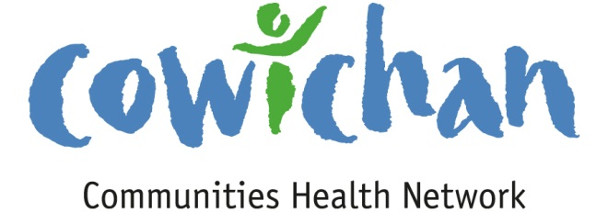

CHECK UP
September 20, 2013

This was a magnificent summer to be out on the water... Super Pods of 60-75 whales came together and I had the good fortune to experience this!
Today’s Check up Includes:

- Meeting Schedules
- Community meetings and Events
- Underlying Premise Evidence- (part 10) Health Services
- Survey ( Time Limited) Telling the Non Profit Sector Story
- Canadian Environmental Health Atlas – Check it Out
- EVENT Posters- Share Freely

CCHN Network Member Meetings-
- Asset Mapping and Research Committee Meeting October 7, 9:00 am room to be announced
- Next CCHN Meeting October 10th, Dinner at 5:30 Meeting Starts at 6:00- CVRD Board Room
- Admin Committee Meeting October 16th at 5:30 CVRD Committee Room 2
Upcoming Events/ Workshops/ Community Meetings

Family Meals Event Friday October 4th at Clements Centre- bring your children to enjoy a free family meal. Doors open at 4:30- Dinner starts at 5:00 and activities follow.

It’s Time Parent Conference- Saturday October 26, 8:30 am to 4:30 pm- Island Savings Centre- see poster below for more information

KEY DETERMINANT – 10 Health Services
UNDERLYING PREMISES

EVIDENCE
Health services, particularly those designed to maintain and promote health, to prevent disease, and to restore health and function contribute to population health. The health services continuum of care includes treatment and secondary prevention
Evidence from the Second Report on the Health of Canadians
Disease and injury prevention activities in areas such as immunization and the use of mammography are showing positive results. These activities must continue if progress is to be maintained.
There has been a substantial decline in the average length of stay in hospital. Shifting care into the community and the home raises concerns about the increased financial, physical and emotional burdens placed on families, especially women. The demand for home care has increased in several jurisdictions, and there is a concern about equitable access to these services.
Access to universally insured care remains largely unrelated to income; however, many low- and moderate-income Canadians have limited or no access to health services such as eye care, dentistry, mental health counselling and prescription drugs.
Telling the BC Non-Profit Sector Story:
Fill Out the Survey by Friday, September 20
Are you a member of a Board of Directors, or employed or volunteering in the non-profit sector in BC? This survey is designed to gather your ideas about the strengths, value and impact of BC non-profits. This survey is one of the first steps in the New Directions for British Columbia's Non-Profit Sector initiative led by SPARC BC, Vancity Community Foundation and VOCBC with funding from the BC Centre for Non-Profit Management and Sustainability. All respondents will also be eligible for an iPad draw. Survey closes 5 pm on Friday, September 20.
Complete the survey here. Find more info on the New Directions Survey and Project here. Questions? Contact Scott Graham at SPARC BC at sgraham@sparc.bc.ca.

The Canadian Environmental Health Atlas Launches: Understanding our environment is key to promoting health and preventing disease
(First Call BC) The online publication Canadian Environmental Health Atlas emphasizes stimulating research and case studies using maps, graphics, videos, infographics and narrative to explain key concepts of environmental health, reports Joanne Telfer, Project Coordinator based out of Simon Fraser University.
The Atlas introduces the many ways the environment affects human health and highlights the importance of environmental health in health promotion and disease prevention. It includes environmental health topics, such as Asbestos, Lead, Heat Waves, SARS and the Aboriginal Community Well-being Index, that are organized under 10 major themes. Please explore the Atlas and share it with others.

Do you have a resource, event or information you would like to share?
Send it to cindylisecchn@shaw.ca and it will be included in the weekly Check UP Newsletter

Please share posters for upcoming events listed below....

↓
↓
↓
↓

Sponsored by the Network for Families Group
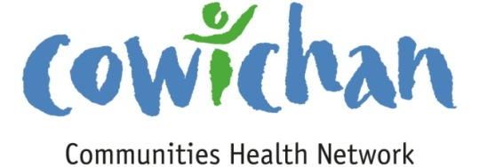

Friday October 4th
at Clements Centre
5856 Clements Street, Duncan
Doors open at 4:30. Dinner at 5:00 – Activities to follow
Bring your children to enjoy a free
Family Meal
Eat together, listen to a story
Activities for children & parents to enjoy together.
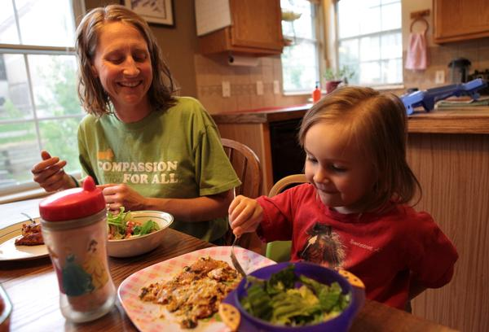
Children who eat with their family Members at least once a day:
Communicate better with their parents
Practice their social skills
5856 Clements Street
Deepen their sense of belonging and security
Do better at school
Eat more vegetables, fruit and calcium rich foods
Learn more words, have a better vocabulary

More Information:
Margaret Moss Health Centre
250-709-3050 local 45509

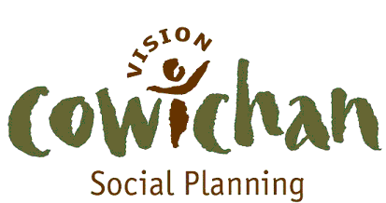

Care Kits

HOMELESSNESS ACTION WEEK 2013
A Day of Direct Services for the Homeless

Wednesday October 16, 2013 - 10:00 am to 3:00
Duncan United Church Hall

Our intent is to bring together government services, not-for-profits, community services, and individual volunteers in a coordinated effort to support those who are most vulnerable in our communities.
A variety of personal care items, clothing and sleeping gear will also be available for guests.

Care Kits:
- Socks , Tooth Brushes, Toothpaste, Soap, Lotion, Shampoo, Lip balm, Combs
- Seasonal clothing: Jackets, hats, scarves, mitts, rain gear,
- Work Clothing
- Blankets
- Tents
- Sleeping Bags
- Boots
- Back Packs
- Sewing Kits
- First Aid Items
- Foot wear
- Feminine hygiene products
- Books
- Granola Bars, Juice Box
- Flashlights
- Razors
- Nail Clippers

Items may be dropped off to Social Planning’s office at 135 Third St.
A donation box is inside the upstairs front door.
We are anticipating 60 to 80 guests. Items will be displayed and they can pick out items of their choosing.

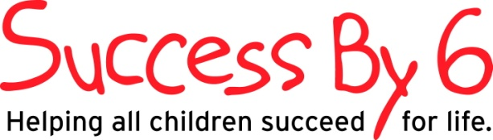
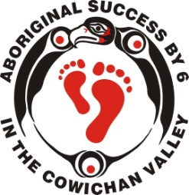
Moms, Dads, Grandparents, Early Childhood Professionals
JOIN US FOR:
-A day of interactive and educational workshops
-Browse through displays and learn about resources in your community
-Great door prizes

Quality child minding available

Presents
It’s Time…..

Saturday October 26th,
8:00 am- 4:30 pm
Island Savings Centre
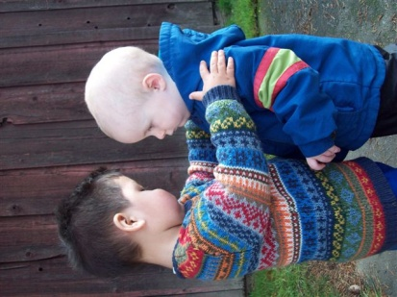
….to talk
….to play
….to sing
….to read

Register Today!
No Cost
Pre registration is required

Includes: 4 workshops, lunch, all snacks and refreshments, child care (limited spaces), door prizes and take home resources!

Deadline to Register: Monday October 21st
Contact Laura Court at cowichansuccessby6@shaw.ca or call 250-701-3647
Or Ada Mawson at ada.mawson@csets.com
Registration forms at www.cowichankids.ca or register in person at Clements Centre- 5856 Clements Street, Duncan

