

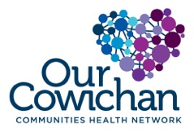

**Health Matters Newsletter**

**August 22, 2014**

**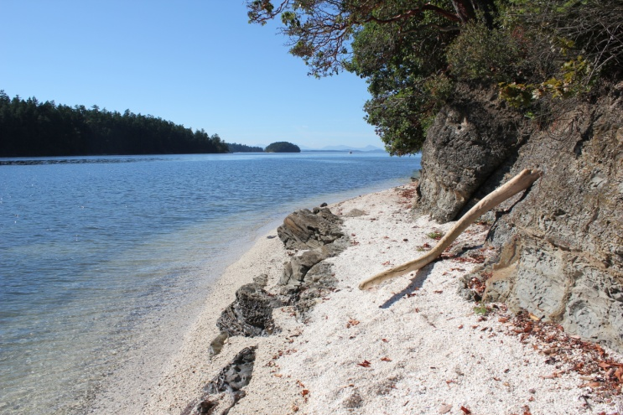**

**Today’s Health Matters Includes:**

* Meeting Schedules
* Community Meetings and Events
* Our Cowichan Small Grants Available

**The gorgeous shell beach at Montague Harbour**

C:\Program Files (x86)\Microsoft Office\MEDIA\OFFICE12\Lines\BD14996_.gif

**Our Cowichan- Network Member Meetings-**

* **Next Our Cowichan Network Meeting –September 11,** CVRD Board Room. Light dinner at 5:30 pm – Meeting starts at 6:00 pm
* **Next Admin Committee Meeting-** Wednesday September 17, 5:30 pm CVRD Committee Room 2
* **Next Grant Committee Meeting-** Wednesday October 1, 9 am to 11 am CVRD – Room to be announced
* **Strategic Planning Sessions** Thursday October 2nd 5 pm to 8 pm and Friday October 3rd 8:30 am to 4:00 pm

C:\Program Files (x86)\Microsoft Office\MEDIA\OFFICE12\Lines\BD14996_.gif**Upcoming Events/ Workshops/ Community Meetings**

C:\Program Files (x86)\Microsoft Office\MEDIA\OFFICE12\Lines\BD14996_.gif



Calls for Proposals

Cowichan Valley

C:\Program Files (x86)\Microsoft Office\MEDIA\OFFICE12\Lines\BD14800_.gifThank you for your interest in contributing to the health of citizens living in the Cowichan Region. Our Cowichan Communities Health Network (OCCHN) is pleased to provide a maximum grant of $2,000.00 toward eligible projects in the Cowichan Valley. Please read the following information to ensure your proposal meets the funding requirements.

Our Cowichan recognizes the health and well -being of our citizens is impacted by the 12 Key determinants of health within the context of healthy and supportive communities, organizations, families and relationships.

Our Cowichan has the opportunity to make a positive and meaningful contribution to our communities’ future. OCCHN is committed to helping all citizens of the Cowichan Communities enjoy good health.

**Project focus:**

Applications whose priorities for action respond to demonstrated community needs, gaps and priorities and that are evidence based and focus on the determinants of health will be accepted for review.

Application templates are available on our website [www.cchn.ca](http://www.cchn.ca) or contact Cindy Lise at [cindylisecchn@shaw.ca](mailto:cindylisecchn@shaw.ca) . Applications will be accepted up to October 1, 2014. Funding announcements will be made by October 15, 2014 or sooner.

* 1 copy must be submitted by email to: cindylisecchn@shaw.ca
* 1 hard copy must be mailed to:

Our Cowichan

PO Box 20106

Duncan BC,

V9L- 5H1

C:\Program Files (x86)\Microsoft Office\MEDIA\OFFICE12\Lines\BD14996_.gif

Do you have a resource, event or information you would like to share?

Send it to [cindylisecchn@shaw.ca](mailto:cindylisecchn@shaw.ca) and it will be included in the weekly

**Health Matters Newsletter**