

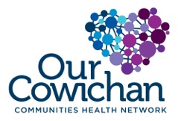

**Health Matters Newsletter**

**May 9, 2014**

**Today’s Health Matters Includes:**

* Meeting Schedules
* Community meetings and Events
* 2011 census data as it relates to early years
* 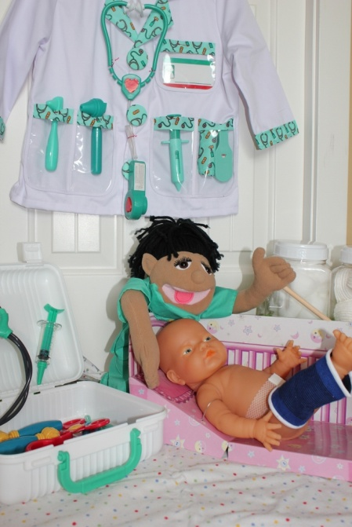BC Communities Health Atlas- on line maps
* E- Cigarettes- the conversation is growing across the globe
* Gathering of Change Makers

**Say Hello to the new friends you will meet at the soon to open “Wendy’s House” Children’s Play and Discovery Centre.** These friends will be found in the Feel Better Centre sponsored by Island Health and Our Cowichan.

C:\Program Files (x86)\Microsoft Office\MEDIA\OFFICE12\Lines\BD14996_.gif

**Our Cowichan- Network Member Meetings-**

* **Next Communications Committee Meeting-** Wednesday May 14- 11:00 am CVRD- Committee Room 1
* **Next Our Cowichan Network Meeting –**Thursday June 12, CVRD Board Room. Light dinner at 5:30 pm – Meeting starts at 6:00 pm
* **Next Admin Committee Meeting-** Wednesday June 18, 5:30 pm Committee Room 2 CVRD
* **Next Asset Mapping and Research Committee meeting-** to be announced

C:\Program Files (x86)\Microsoft Office\MEDIA\OFFICE12\Lines\BD14996_.gif

**Upcoming Events/ Workshops/ Community Meetings**

* Gathering Change Makers with Dr Paul Hasselback – May 13 New Life Baptist Church-
* Walk of the Nations May 31 starting 10 am at VIU- see attached poster

C:\Program Files (x86)\Microsoft Office\MEDIA\OFFICE12\Lines\BD14996_.gif

**Regional Affordable Housing Needs Assessment**

The CVRD, with the assistance of CitySpaces Consulting Ltd., is conducting a Regional Affordable Housing Needs Assessment.  The study is intended to identify the types of housing that are needed throughout the region, including its municipalities of Duncan, North Cowichan, Ladysmith and Lake Cowichan, and electoral areas. The study will also identify population groups with the most significant housing needs. Information including a [**CVRD Housing Indicators Report**](http://www.cvrd.bc.ca/DocumentCenter/View/63345) is available at [www.cvrd.bc.ca/housing](http://www.cvrd.bc.ca/housing).  **Your input is needed!** Input can be provided in a couple of different ways:

[**CoMap**](http://www.comap.co/p/cvrd-affordable-housing-needs-assessment.html)– have ideas or concerns about housing in a particular community or location?  Provide comments directly through CoMap.

Take the [**Regional Affordable Housing Survey**](http://fluidsurveys.com/s/cvrd-housing-survey/). The survey will run until May 23rd.

Visit your local community centre and check out our **post-it posters**.

More information is available at [www.cvrd.bc.ca/housing](http://www.cvrd.bc.ca/housing).

Please distribute this email to your networks!

Ann

Ann Kjerulf, MCIP, RPP

Senior Planner, Community & Regional Planning Division

Planning & Development Department

Cowichan Valley Regional District

175 Ingram Steet, Duncan BC  V9L 1N8

Email: [akjerulf@cvrd.bc.ca](mailto:akjerulf@cvrd.bc.ca)

Tel: 250.746.2629   Toll Free: 1.800.665.3955   Fax: 250. 746.2621

C:\Program Files (x86)\Microsoft Office\MEDIA\OFFICE12\Lines\BD14996_.gif

# Plenty of potential hospital sites to choose from

Signs point to a new Cowichan Hospital being purchased as soon as possible, but the process is still expected to take quite some time.

*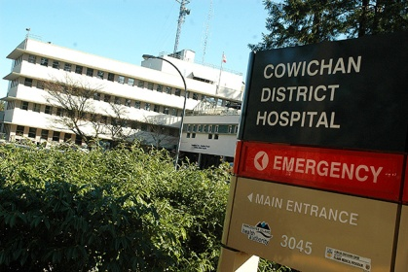*— image credit: Peter W. Rusland/file

by  [Peter Rusland - Cowichan News Leader Pictorial](http://www.cowichannewsleader.com/staff_profiles/10868196.html)posted Apr 30, 2014 at 9:00 AM

Cowichanians know plenty of places our new hospital can go. Thirty-eight, in fact. Rob Hutchins, Cowichan Valley Regional District chairman, says a recent public call for site suggestions for the planned Cowichan District Hospital reached 41 ideas, though three were overlaps.

“We actually received 20 site ideas, and our site selection consultant identified another 21,” he told the News Leader Pictorial.

“It certainly exceeded my expectations.

“I believe there were 38 site that met the criteria. This is excellent news.”

Site-musts listed by a technical committee, comprising agents with the CVRD, Island Health, and McElhanney consulting engineers, span access to an air ambulance corridor, access to community services such as water and sewer lines, location outside Cowichan’s floodplain, proximity to major roads, a quiet, healing location, and more.

The land must also measure about 15 acres to meet current needs, and future growth — and fit local official community plan guidelines, Hutchins explained.

The criteria will now be fine-tuned to filter the 38 candidate sites. He expected a short-list by mid-May. Then a more detailed evaluation process will whittle the suggested sites further. Hutchins was unaware of specific locations.

The new CDH might go to replace the 45-year-old facility off Gibbins Road, where a chronic shortage of staffed beds plagues a maximum patient load. An IH master-site plan explained a passel of problems if the new hospital were built there. For one thing, CDH’s vital medivac helipad would be grounded during four to five years of construction.

The Gibbins site is also sloped, posing seismic and design glitches. Disruption of patients and staff, plus additional construction costs — before the current facility was demolished — posed worries too.

Those issues would also plague an option of adding new wings to asbestos-lined CDH, officials have explained.

“The recommendation from the master site plan is to look for another site,” Hutchins said of Island Health’s 2010-11 documents. It’s ordered mapping of the valley’s 500-year flood areas to ferret historically dry properties — of various, unknown prices — for the new CDH, which is estimated to cost about $350 million-plus, and serve Cowichanians for about 50 years.

C:\Program Files (x86)\Microsoft Office\MEDIA\OFFICE12\Lines\BD14996_.gif

# Lake Cowichan Kids Island’s least prepared for school

by  [Ross Armour - Cowichan News Leader Pictorial](http://www.cowichannewsleader.com/staff_profiles/196387151.html)

posted Apr 30, 2014 at 1:00 PM

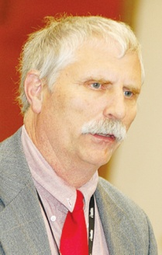Dr. Paul Hasselback

— image credit: Peter W. Rusland/file

More than half of the children in the Cowichan Lake area are entering school for the first time without the required skills to start.

This is according to Island Health, which has confirmed the community has the worst Early Development Index — essentially a measure of children’s well-being prior to entering school — on Vancouver Island.

“When children are showing up for school for the first time, they are not ready to start as well as what they were two, four and six years ago,” said Dr Paul Hasselback from Island Health at last Tuesday’s regular council meeting at the town hall in Lake Cowichan. “Our message to council is that there is a greater need to pay attention to this. Over 50% of the children in the Lake Cowichan area are not prepared to start school,.”

This news came as part of an update Hasselback was making to council on the state of healthcare and well-being in Lake Cowichan and the surrounding areas.

“A large percentage of Lake Cowichan’s population is in the 50 to 70 years of age range. For us, this is a large geographic area that expands all the way out to Ditidaht, but it has a low population. The life expectancy is approximately the same as the island, which is the same as B.C., and that is affected by that low population, so I wouldn’t interpret that with too much depth.”

Councillor Frank Hornbrook had some suggestions on the poor EDI stats.

“If both parents are working until 5 p.m. and then they have to pick their child up and just get them ready for bed, maybe then they just can’t see them as often as they should or can do,” said Hornbrook.

Hasselback agreed and stated he’s heard all kinds of theories.

“There could well be a link between the amount of time the parents see their kids during the day as well as the environment that a child is being raised in,” he said.

Nevertheless, Hasselback chose to end the conversation on a high note and praised the recent influx of healthcare professionals to the town, as well as the work of Choose Cowichan Lake.

“There is a high rate of asthma and chronic lung disease in the Cowichan Valley, but that is lower in Lake Cowichan.”

Mayor Ross Forrest finished by saying that he hopes to see current Lake residents who are heading outside of the area to visit a doctor or gain medical aid and advice return home, so the new healthcare professionals in town “stay busy so we can keep them.”

C:\Program Files (x86)\Microsoft Office\MEDIA\OFFICE12\Lines\BD14996_.gif

**For Immediate Release: April 30th, 2014**

**Event: Kin Fest**

**When:** May 10th, 2014, 12p.m.-4p.m.

**Where:** Kin Park Youth Urban Farm. Alderlea St, between James and Coronation

**Contact:** Brittany Lowe

**Tel:** 250.748.8506.

**Email:** [Brittany@cowichangreencommunity.org](mailto:Brittany@cowichangreencommunity.org)

**Come Out and Have Fun at Kin Fest!**

Cowichan Green Community (CGC) is excited to host Kin Fest, FREE all-inclusive, all-fun event inviting youth and their families in the Cowichan Region to come out and enjoy Kin Park. The event will feature a range of entertaining and kid-friendly activities, including; face painting, henna tattoos, cedar rose making workshops, gardening, live music, open mic, arts and crafts, sports, and a BBQ. As well, Scouts Canada will make a special appearance to host a water balloon throwing competition!

We are seeking feedback on how to make our park more fun, inviting and appealing to youth and their families. We hope to gather participant’s ideas on how to increase the availability of the park to their interests by requesting that participants fill out a questionnaire and/or speak to the event’s hosts regarding their experience at, and future expectations of, the park.

**Admission:** There is no admission fee for this event.

**Food:** The BBQlunch is free and will be served from 12p.m.-1p.m. Hot dogs, hamburgers, and veggie alternatives, salads, fruit and veggie trays (sourced from local growers and producers) will be provided.

**What to Bring:** If it is available to participants, we request that people bring their own utensils in order to cut down the amount of waste we produce at the event. If you wish to bring a blanket and/or a chair to sit on this is welcomed.

**Parking:** Free parking is available along Alderlea, Queens, and James.

For more information on this event, please contact Brittany Lowe, Community Action Initiative (CAI) Grant Project Assistant at Cowichan Green Community. Email: Brittany@cowichangreencommunity.org. Phone: 250.748.8506. Website: [www.cowichangreencommunity.org](http://www.cowichangreencommunity.org)

Additional information regarding the event can be found in the events section on our Facebook and Twitter pages, titled; Kin Park Youth Urban Farm. Funding provided by Community Action Initiative.

C:\Program Files (x86)\Microsoft Office\MEDIA\OFFICE12\Lines\BD14996_.gif

Do you have a resource, event or information you would like to share?

Send it to [cindylisecchn@shaw.ca](mailto:cindylisecchn@shaw.ca) and it will be included in the weekly Health Matters Newsletter