



**Health Matters Newsletter**

**May 16, 2014**

**Today’s Health Matters Includes:**

* Meeting Schedules
* Community meetings and Events
* Determinants of Health Image
* Million Dollar Murray
* Welcome to Wendy’s House
* Video- Van City’s Living Wage Campaign
* Homelessness and Health In Canada
* Social Determinants of Health and Children In Canada

C:\Program Files (x86)\Microsoft Office\MEDIA\OFFICE12\Lines\BD14996_.gif

**Our Cowichan- Network Member Meetings-**

* **Next Grant Committee Meeting-** Tuesday May 20 1:00 pm CVRD Committee Room 1
* **Next Asset Mapping and Research Committee meeting-** June 2 -12 pm CVRD Committee Room 2 ***and*** June 9 12 pm CVRD Rooms 213
* **Next Our Cowichan Network Meeting –**Thursday June 12, CVRD Board Room. Light dinner at 5:30 pm – Meeting starts at 6:00 pm
* **Next Admin Committee Meeting-** Wednesday June 18, 5:00 pm CVRD Committee Room 2

C:\Program Files (x86)\Microsoft Office\MEDIA\OFFICE12\Lines\BD14996_.gif

**Upcoming Events/ Workshops/ Community Meetings**

* Walk of the Nations May 31- Meet at VIU at 9:30 am- Wear Traditional Costumes

C:\Program Files (x86)\Microsoft Office\MEDIA\OFFICE12\Lines\BD14996_.gif

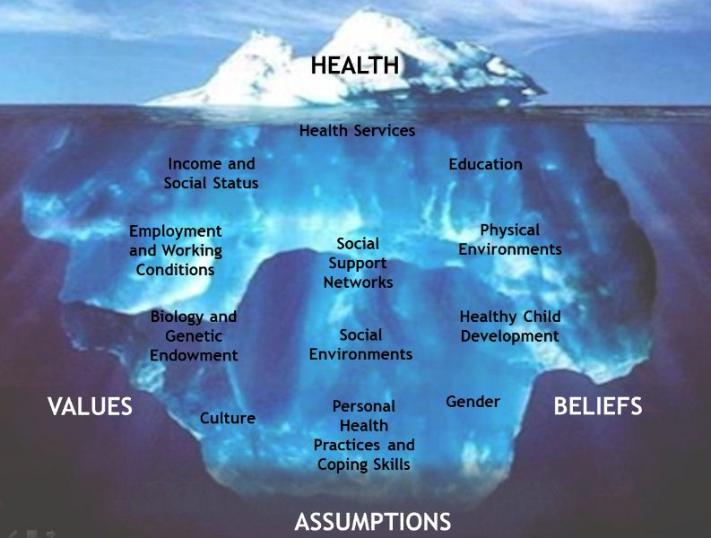

# C:\Program Files (x86)\Microsoft Office\MEDIA\OFFICE12\Lines\BD14996_.gif

# Million-Dollar Murray

Posted February 13, 2006 by [Malcolm Gladwell](http://gladwell.com/author/malcolm/) & filed under [Dept. of Social Services](http://gladwell.com/category/the-new-yorker-archive/dept-of-social-services/), [The New Yorker - Archive](http://gladwell.com/category/the-new-yorker-archive/).

**Why problems like homelessness may be easier to solve than to manage.**

Murray Barr was a bear of a man, an ex-marine, six feet tall and heavyset, and when he fell down—which he did nearly every day—it could take two or three grown men to pick him up. He had straight black hair and olive skin. On the street, they called him Smokey. He was missing most of his teeth. He had a wonderful smile. People loved Murray.

His chosen drink was vodka. Beer he called “horse piss.” On the streets of downtown Reno, where he lived, he could buy a two-hundred-and-fifty-millilitre bottle of cheap vodka for a dollar-fifty. If he was flush, he could go for the seven-hundred-and-fifty-millilitre bottle, and if he was broke he could always do what many of the other homeless people of Reno did, which is to walk through the casinos and finish off the half-empty glasses of liquor left at the gaming tables.

“If he was on a runner, we could pick him up several times a day,” Patrick O’Bryan, who is a bicycle cop in downtown Reno, said. “And he’s gone on some amazing runners. He would get picked up, get detoxed, then get back out a couple of hours later and start up again. A lot of the guys on the streets who’ve been drinking, they get so angry. They are so incredibly abrasive, so violent, so abusive. Murray was such a character and had such a great sense of humor that we somehow got past that. Even when he was abusive, we’d say, ‘Murray, you know you love us,’ and he’d say, ‘I know—and go back to swearing at us.”

“I’ve been a police officer for fifteen years,” O’Bryan’s partner, Steve Johns, said. “I picked up Murray my whole career. Literally.”

Johns and O’Bryan pleaded with Murray to quit drinking. A few years ago, he was assigned to a treatment program in which he was under the equivalent of house arrest, and he thrived. He got a job and worked hard. But then the program ended. “Once he graduated out, he had no one to report to, and he needed that,” O’Bryan said. “I don’t know whether it was his military background. I suspect that it was. He was a good cook. One time, he accumulated savings of over six thousand dollars. Showed up for work religiously. Did everything he was supposed to do. They said, ‘Congratulations,’ and put him back on the street. He spent that six thousand in a week or so.”

Often, he was too intoxicated for the drunk tank at the jail, and he’d get sent to the emergency room at either Saint Mary’s or Washoe Medical Center. Marla Johns, who was a social worker in the emergency room at Saint Mary’s, saw him several times a week. “The ambulance would bring him in. We would sober him up, so he would be sober enough to go to jail. And we would call the police to pick him up. In fact, that’s how I met my husband.” Marla Johns is married to Steve Johns.

“He was like the one constant in an environment that was ever changing,” she went on. “In he would come. He would grin that half-toothless grin. He called me ‘my angel.’ I would walk in the room, and he would smile and say, ‘Oh, my angel, I’m so happy to see you.’ We would joke back and forth, and I would beg him to quit drinking and he would laugh it off. And when time went by and he didn’t come in I would get worried and call the coroner’s office. When he was sober, we would find out, oh, he’s working someplace, and my husband and I would go and have dinner where he was working. When my husband and I were dating, and we were going to get married, he said, ‘Can I come to the wedding?’ And I almost felt like he should. My joke was ‘If you are sober you can come, because I can’t afford your bar bill.’ When we started a family, he would lay a hand on my pregnant belly and bless the child. He really was this kind of light.”

In the fall of 2003, the Reno Police Department started an initiative designed to limit panhandling in the downtown core. There were articles in the newspapers, and the police department came under harsh criticism on local talk radio. The crackdown on panhandling amounted to harassment, the critics said. The homeless weren’t an imposition on the city; they were just trying to get by. “One morning, I’m listening to one of the talk shows, and they’re just trashing the police department and going on about how unfair it is,” O’Bryan said. “And I thought, Wow, I’ve never seen any of these critics in one of the alleyways in the middle of the winter looking for bodies.” O’Bryan was angry. In downtown Reno, food for the homeless was plentiful: there was a Gospel kitchen and Catholic Services, and even the local McDonald’s fed the hungry. The panhandling was for liquor, and the liquor was anything but harmless. He and Johns spent at least half their time dealing with people like Murray; they were as much caseworkers as police officers. And they knew they weren’t the only ones involved. When someone passed out on the street, there was a “One down” call to the paramedics. There were four people in an ambulance, and the patient sometimes stayed at the hospital for days, because living on the streets in a state of almost constant intoxication was a reliable way of getting sick. None of that, surely, could be cheap.

O’Bryan and Johns called someone they knew at an ambulance service and then contacted the local hospitals. “We came up with three names that were some of our chronic inebriates in the downtown area, that got arrested the most often,” O’Bryan said. “We tracked those three individuals through just one of our two hospitals. One of the guys had been in jail previously, so he’d only been on the streets for six months. In those six months, he had accumulated a bill of a hundred thousand dollars—and that’s at the smaller of the two hospitals near downtown Reno. It’s pretty reasonable to assume that the other hospital had an even larger bill. Another individual came from Portland and had been in Reno for three months. In those three months, he had accumulated a bill for sixty-five thousand dollars. The third individual actually had some periods of being sober, and had accumulated a bill of fifty thousand.”

The first of those people was Murray Barr, and Johns and O’Bryan realized that if you totted up all his hospital bills for the ten years that he had been on the streets—as well as substance-abuse-treatment costs, doctors’ fees, and other expenses—Murray Barr probably ran up a medical bill as large as anyone in the state of Nevada.

“It cost us one million dollars not to do something about Murray,” O’Bryan said.C:\Program Files (x86)\Microsoft Office\MEDIA\OFFICE12\Lines\BD14996_.gif

# Welcome to Wendy’s house

Working with children brought Wendy Erickson great joy.

— image credit: submitted

* [0](http://www.cowichannewsleader.com/news/258514181.html#storyComments)By  [Don Bodger - Cowichan News Leader Pictorial](http://www.cowichannewsleader.com/staff_profiles/10867791.html)
* posted May 13, 2014 at 8:00 AM

Wendy Erickson knew a children’s centre named in honour of her was in the works.

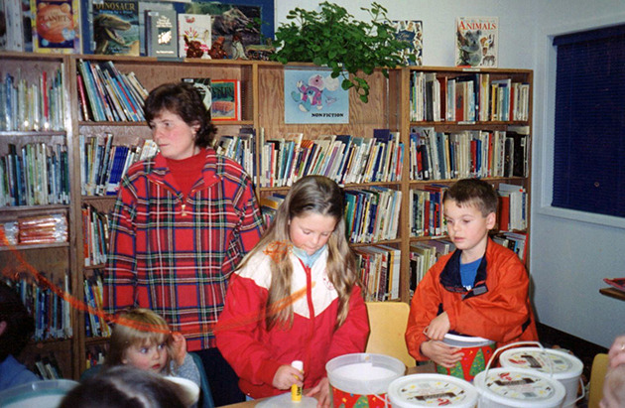Erickson, who died of cancer two days after her 50th birthday in March, long had a vision for a children’s centre in the valley and worked tirelessly on building literacy skills for young children in her role as community early literacy co-ordinator for School District 79.

The fruits of her passion are going to be realized. SD79 — in conjunction with community partners, — has been working on developing a play and discovery centre for children up to five years old and their parents or caregivers.

The centre will feature interactive play areas where children can laugh and learn through play. The play areas will include a restaurant, fire station/rescue centre, office, tugboat and marina, construction site, store, Coast Salish village, health clinic, fitness centre, art studio and a tree house.

Since it was Erickson’s initiative, her legacy will be honoured with the centre being named Wendy’s House. It’s expected to open in June.

It will be housed in portables located on the old Pioneer Park ball fields along the Trans-Canada Highway and next to Vancouver Island University.

Wendy’s husband Jamie indicated former trustee and community liaison Candace Spilsbury and SD 79 Director of Elementary Education Linda McMenamin visited Wendy a month before she died, showed her drawings of the centre and let her know their plans of naming it after her.

“Although truly honoured to have the centre named for her, Wendy’s greatest joy would be in seeing her dream and vision, all her tireless devotion come to completion,’’ pointed out Jamie.

“As a family we are pleased and honoured to have Wendy recognized for all her never-ending work for the children of the Cowichan Valley.”

“Wendy was all about the kids and finding ways to support their learning in fun and meaningful ways,’’ stated Sheryl Koers, SD79 assistant superintendent, in a news release. “She had a huge impact on the school community and she made a difference for so many children. We are pleased to be working towards making Wendy’s dream a reality.’’

Wendy’s long teaching career in the district included primary classes, special education, learning assistance and reading recovery at Crofton, Mount Brenton and Koksilah Elementarys. She was appointed district co-ordinator in 2004 and besides supporting early learning in primary classrooms; she initiated new learning ventures such as Fun Family Literacy Nights, Ready, Set Learn and the Parents As Literacy Partners program in the schools.

Jamie noted Wendy’s vision has been a dream since she first started on her job and served as SD79 representative on the Island Literacy Committee. She was taken to see Munchkinland, Parksville’s child care centre, during a conference there and knew immediately this was something the valley needed.

“From that day on, every opportunity Wendy had to speak about her dream, she took it,’’ Jamie indicated. “Whether it was a staff meeting, community meetings or speaking with colleagues, it was never far from her mind. Every trip up-island we took, we had to stop in to take one more look to see if they had come with any new ideas.’’Besides her family, Wendy’s other passion was field hockey. She coached the Frances Kelsey senior girls for several years and it’s expected some recognition of her contribution in that sport will be made in the future.

**C:\Program Files (x86)\Microsoft Office\MEDIA\OFFICE12\Lines\BD14996_.gif**

**Vancity video encourages employers to join the Living Wage for Families Campaign**  
   
Here’s a great [new video](http://cts.vresp.com/c/?FirstCallBCChildandY/d54c17cb2c/321050fb30/adb43fb4a5/v=h19VZlo-W6o) from Vancity about the value of being a Living Wage Employer. In it, Virginia Weiler, chair of the Vancity board of directors, calls the living wage “a modern-day equivalent of creating financial access and inclusion.”

Vancity set a precedent when it became the largest organization in Canada to become a Living Wage Employer on May 24, 2011. Their new video shares how a living wage makes a difference to their employees, contractors, suppliers and communities, and urges other employers to join the Living Wage for Families Campaign.

Watch the [video](http://cts.vresp.com/c/?FirstCallBCChildandY/d54c17cb2c/321050fb30/266b168dcc/v=h19VZlo-W6o) (2:41 min.)

C:\Program Files (x86)\Microsoft Office\MEDIA\OFFICE12\Lines\BD14996_.gif

**Homelessness & Health in Canada - New report from the University of Ottawa**  
   
[Homelessness & Health in Canada](http://cts.vresp.com/c/?FirstCallBCChildandY/d54c17cb2c/321050fb30/781b688074) explores, for the first time, the social, structural and environmental factors that shape the health of homeless persons in Canada. Covering a range of topics from youth homelessness to end-of-life care, the authors outline policy and practice recommendations.  
   
Part I – Homelessness & Health in Canadian Populations includes the chapter, “Being Young and Homeless: Addressing Youth Homelessness from Drop-in to Drafting Policy.”  
  
Find the [complete report](http://cts.vresp.com/c/?FirstCallBCChildandY/d54c17cb2c/321050fb30/78054e577f), published by the University of Ottawa Press (PDF, 331 pages)  
  
Thanks to the Canadian Social Research Newsletter for bringing this resource to our attention.

C:\Program Files (x86)\Microsoft Office\MEDIA\OFFICE12\Lines\BD14996_.gif

**Social Determinants of Children’s Health in Canada: Analysis and Implications**  
   
The health of Canada’s children when placed in comparative perspective with other wealthy developed nations is mediocre at best. Much of this has to do with the social determinants of children’s health (SDCH) in Canada being of generally lower quality and more inequitably distributed than is the case in most other wealthy developed nations.  
   
In this report published in the International Journal of Child, Youth and Family Studies, health policy professor Dennis Raphael concludes:  
   
“The literature on the SDCH is providing increasing evidence that the primary means of improving their quality and making the distribution more equitable is through public policy that provides parents with the economic and social security necessary for health. These public policy areas shape all the SDCH of early childhood development, income and wealth distribution, employment security and working conditions, food and housing security, and the provision of health and social services. This argument outlines a major role for the State – acting on behalf of the majority of citizens – in taking an active role in the provision of economic and social security for citizens. Without such government intervention, the economic system creates the social inequalities that shape the quality and distribution of the SDCH. In nations such as Canada where there is growing withdrawal of the State from involvement in these areas, we see evidence of either stagnating or declining health of children.”  
   
Read the [full report](http://cts.vresp.com/c/?FirstCallBCChildandY/d54c17cb2c/321050fb30/daf6db5717)  
   
Thanks to the BC Aboriginal Child Care Society e-news for bringing this research to our

C:\Program Files (x86)\Microsoft Office\MEDIA\OFFICE12\Lines\BD14996_.gif

Do you have a resource, event or information you would like to share?

Send it to [cindylisecchn@shaw.ca](mailto:cindylisecchn@shaw.ca) and it will be included in the weekly Health Matters Newsletter