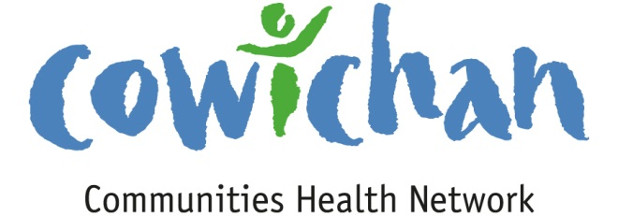

CHECK UP
March 29, 2013
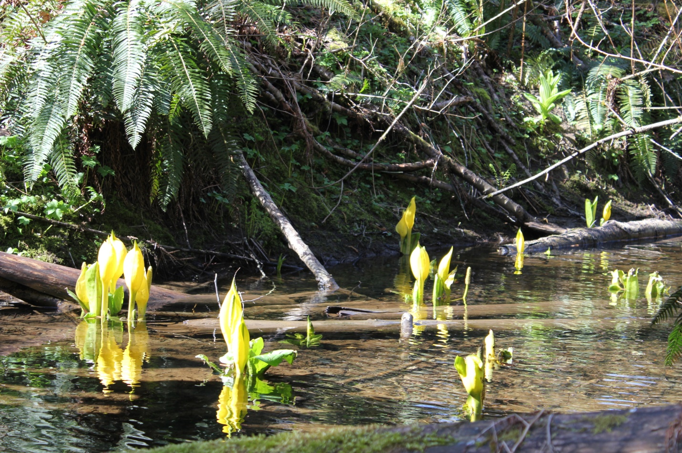
Spring has sprung!!! Even the smelly skunk cabbages are gorgeous along the Cowichan River Trail heading out from the Glenora Trail Head. It is easy walking so give it a try!

Today’s Check up Includes:
- Meeting Schedules
- Video- Cowichan Lodge Reopens!
- Suicide and Prevention Workshop
- Video on Social Determinants of Health produced by Vancouver Coastal Health
- Article on impact of poverty on early childhood brain development
- Inviting Voice Creating Space research project- backgrounder
CCHN Network Member Meetings-

Communications Committee Meeting- Tuesday April 2nd at 3:30- Room to be determined- An email will be sent out Tuesday morning.
Grant Committee Meeting- Monday April 8th 4:00 pm – Committee Room 2 CVRD
Asset Mapping and Research Committee Meeting – Tuesday, April 9th 4:00 pm –Ladysmith Health Centre- All welcome- Please invite organizations who are interested in exploring asset mapping and research to join us.
Upcoming Events/ Workshops/ Community Meetings

- Strengthening Protective Factors in Community –

April 3rd 9:00 to 12:00 Silver Bridge Inn
In recognition of Crisis Line Awareness Week, the Vancouver Island Crisis Society is offering a FREE Suicide Prevention & Support workshop, highlighting suicide prevention strategies for youth, adults, and those bereaved by suicide.
This workshop is for anyone interested in learning current research-based information about suicide prevention.
Through interactive presentations, discussions, exploration and practice, participants will learn:
- Fears about suicide and tools for overcoming them
- Myths and misinformation
- How to recognize Warning Signs and respond to a suicidal person
- Responding to the threat of suicide
- How to respond to and talk about suicide with youth
- Creating a safe plan that includes community resources
- How the crisis line can be your support
Workshops are taking place in Tofino, Ucluelet, Campbell River, Courtenay, Victoria, Port Hardy, Port Alberni, Duncan, and Nanaimo.
Detailed information is available in our flyer.
Please note that you will not be considered as having registered until you have sent a completed registration form (below) to the Crisis Society. You will be sent an email to confirm your participation, with directions to the training site, a week or so before the training date for the workshop.
To register, please fill out our online form or access our fax registration form.

Connecting the Dots..... As the facilitator goes out and engages in conversations or attends meetings in the community important information is learned along the way that may benefit or be of interest to Network Colleagues- A synopsis of conversations will now be shared in the connecting the dots section.
None this week...

Video: Cowichan Lodge Reopens for Mental Health Care
Cowichan Valley and Vancouver Island seniors and adults with persistent mental illness have improved access to the care they need with the unveiling today of two newly renovated wings at Cowichan Lodge. The $9 million renovation includes a 24-bed wing for seniors who have cognitive and behavioral challenges and a 27-bed wing for adults with severe mental disorders.

http://vimeo.com/60607472

Social Determinants of Health Video
I encourage you to watch a video produced by Vancouver Coastal Health about social determinants of health. The video has two parts. Click to view Part One. Click to view Part Two.
An interesting article on Poverty and early childhood brain development- Check it out
http://www.theglobeandmail.com/technology/science/brain/how-poverty-influences-a-childs-brain-development/article7882957/
Inviting Voice Creating Space-Exploring barriers to participation for women through action research in the Cowichan Valley

A safe community is one where all people – regardless of gender, race, culture, age, income, sexuality, language or ability - can participate fully and freely in all aspects of community life. However, living in poverty and on the social margins, combined with barriers such as historical oppression, violence, poverty and racism, limit access to health care and create health inequities. 1 (Kurtz et al., 2008; Brown, Varcoe & Calam, in press).

Here in the Cowichan Valley, a number of supportive services, recreational opportunities and community resources exist to enrich the lives of women and their families. There are parenting classes, services to support immigrant people, parks, recreational activities and community events, health services, and a wide variety of other opportunities for women to both access support and to participate in community life.
Many local women utilize and safely enjoy these community assets on a daily basis. But what about those who don’t use much needed services, who don’t participate in events and programs, who feel that they can't, or who choose not to for reasons of their own? What is preventing them from getting the services that they may need, from being included in the activities that others enjoy, from feeling welcomed and safe to fully participate in their communities?
This is the question that the Inviting Voice/Creating Space action research project aims to explore. By engaging local women in storytelling, knowledge creation and knowledge translation, we hope to hear about:
- What barriers exist – individual, systemic and political – that hinder women from full participation in community life?
- How are women’s ability to participate in community life impacted by their experiences of social exclusion?
- What do women need to safely participate in community life? What actions will facilitate safety, well-being and social inclusion as health promotion strategies?

This project will develop an understanding of Cowichan women’s experiences of marginalization and social exclusion as the basis for community action. The information gathered will be used to develop a collaborative strategy for women’s health action in the Cowichan Valley and generate locally relevant actions at both service and policy levels.
Inviting Voice/Creating Space is a project of Safer Futures (CWAV Society) in partnership with UBC School of Nursing and funded by the Vancouver Foundation. IVCS was developed by a Project Advisory made up of service providers, women community members and researchers including representatives of CWAV Society, Lalum’utul’ Smuneem/Cowichan Tribes, VIHA, Cowichan Intercultural Society, Cowichan Independent Living and Hiiye'yu Lelum Society.

Cowichan Valley Safer Futures Program / CWAV Society 103-255 Ingram Street, Duncan BC V9L 1P3 Tel: 250-748-7000 www.saferfutures.org

