****

**Health Matters**

**March 28, 2014**

**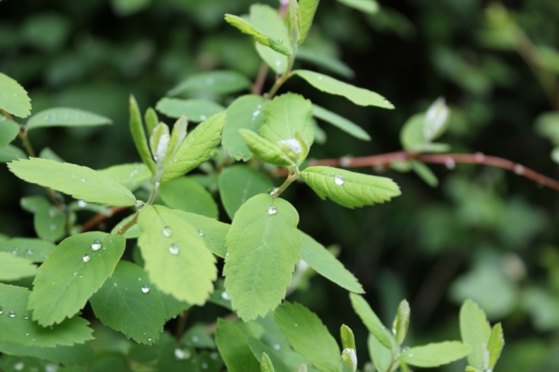**

**Today’s Check up Includes:**

* Meeting Schedules
* Community meetings and Events
* Health Survey- Link for sharing broadly
* Information on Electronic Cigarettes- (attachment)
* Seedy Sunday
* Prevention Against Violence Week
* Hike for Hospice (Attachment)
* Clothesline Project (Attachment)

C:\Program Files (x86)\Microsoft Office\MEDIA\OFFICE12\Lines\BD14996_.gif

**Our Cowichan- Network Member Meetings-**

* **Asset Mapping and Research Committee Meeting-** Monday March 31, 1:00 pm Committee Room 1 - CVRD
* **Next Our Cowichan Network Meeting –**Thursday April10, CVRD Board Room. Light dinner at 5:30 pm – Meeting starts at 6:00 pm
* **Next Admin Committee Meeting-** Wednesday April 17, 5:30 pm CVRD committee room 2

C:\Program Files (x86)\Microsoft Office\MEDIA\OFFICE12\Lines\BD14996_.gif

**Upcoming Events/ Workshops/ Community Meetings**

* **Seedy Sunday – March 30** Sunday,March 30, 2014**-**Si’em Lelum Gymnasium (5574 River Road, Duncan, BC)**-**10am-2pm- $2.00 Admission

**Contact:** Vanessa Goodall – vanessa@cowichangreencommunity.org

* **Cowichan Aboriginal Festival of Film and Art-** April 23-26 at the Cowichan Theatre. Tickets at Cowichan Ticket Centre- Films- Workshops- Art- Performance- Focus Groups- Youth Awards Night- for more info go to [www.aff.cowichan.net](http://www.aff.cowichan.net)

C:\Program Files (x86)\Microsoft Office\MEDIA\OFFICE12\Lines\BD14996_.gif

**Cowichan Health Survey**

**WE WANT TO HEARFROM YOU!**

The purpose of this survey is to collect information from the communities served by ***Our Cowichan Communities Health Network*** to gain a better understanding of the current health and wellness of our residents. The information collected will be used to develop a Community Health Profile for the Cowichan region. This profile will ultimately be used to identify where we are doing well as well as gaps or barriers that impact health.  We will learn from this information and will work together to find community based solutions to improve the health of our communities and residents.

***We kindly ask that you complete the survey and that you share this link far and wide across the Cowichan Region.*** *( A pdf version has also been attached for you to print )*

**YOUR SURVEY RESPONSE WILL BE ANONYMOUS**

<http://fluidsurveys.com/s/CowichanCommunityHealthSurvey/>

C:\Program Files (x86)\Microsoft Office\MEDIA\OFFICE12\Lines\BD14996_.gif

**For Immediate Release: March 25, 2014**

**Event:** Duncan Seedy Sunday

**When:** Sunday,March 30, 2014

**Where:** Si’em Lelum Gymnasium (5574 River Road, Duncan, BC)

**Time:** 10am-2pm

**Contact:** Vanessa Goodall – vanessa@cowichangreencommunity.org

**Who’s Your *Seed* Farmer? Find out at the Duncan Seedy Sunday!**

For a sixth year in a row, the Cowichan Green Community (CGC) is proud to announce that Duncan’s seedy event will take place on SUNDAY, March 30 from 10am-2pm.

Hosted at Cowichan Tribes Si’em Lelum Gymnasium ([5574 River Road, Duncan, BC](https://www.google.ca/maps/vt/data=Ay5GWBeob_WIPLDYoIWcfVXxvZu9XwJ55OX7Ag,tLohOTyFrhsn3pCDhnXgvCDvAoyOBFGbhsszDN62Mv2q93T0A2swd-ZkfI8lzNL1walAsCqQYHo-36cJizdN5PKBjpH-kthj7gF3Dna1)), this family-friendly event will feature a diverse mix of regional seed, plant and garden vendors, kids’ gardening activities, and non-profit booths sharing information on regional seed projects, pollinator conservation, GMO advocacy, and more!

As in seasons past, focal to this year’s event will be the seed exchange and trading table, where we encourage everyone to stop by and swap their food and floral seeds. If you’re not already a seed saver, make sure to ask how you too can get involved! In addition, there will be a series of four seed saving workshops hosted by local seed experts. From a wild seed saving workshop with Sheila Wray, to a grain workshop with Makaria Farm’s Heather McLeod, the workshops will address the principles of seed saving from an array of perspectives.

New to this year’s event will be a space for vendors and event patrons to share their seed stories. CGC is working on a new project to collect and share stories about local seed production and we’d love to hear your favourite seed story. Whether it’s about your family’s treasured bean seed, a favoured late blight resistant tomato, or seed saving mishaps, we want to hear your stories and to learn more about what inspires you to save seed.

“This is key opportunity for the public to meet face-to-face with the farmers who produce locally adapted seed,” shares Tessa Stiven, a CGC coordinator. “Seed producers are key players in our agricultural system, and at CGC we want to encourage gardeners and consumers to not only ask

‘who’s your farmer’ but to ask ‘who’s your seed producer’. As the impacts of climate change affect our growing season, the use of locally adapted seeds will help to ensure growing success!”

Admission to this event is $2.00, with proceeds going to fund this year’s event.

For the complete workshop schedule and the vendor list, please visit: <http://www.cowichangreencommunity.org/content/duncan-seedy-sunday>

For more information on this event, please contact the Cowichan Green Community at 250-748-8506 or [vanessa@cowichangreencommunity.org](mailto:vanessa@cowichangreencommunity.org)

***Workshop Schedule:***

1.) 10:15am-11:00am - **Biennial Workshop** with Robin Sturley of Edible Earth Seeds

2.) 11:15am-12:00pm - **Supporting Bees for Seed Success** with Meg Loop of the Cowichan Land Trust

3.) 12:15pm-1:00pm - **Grow Your Own Pancakes: Growing Grains at a Garden Scale** with Heather McLeod of Makaria Farm

4.) 1:15pm-2:00pm - **Blowing in the Wind: A Wild Seed Savers Workshop** with Sheila Wray of HedgeWhych Wylds

C:\Program Files (x86)\Microsoft Office\MEDIA\OFFICE12\Lines\BD14996_.gif

**Prevention of Violence Against Women Week**

Prevention of Violence Against Women Week” is April 13th – 19th 2014. In 1995 the NDP government took initiative to declare one week in April as Prevention of Violence Against Women Week in British Columbia. This decision effectively began a movement to encourage the public to express its commitment to reducing and preventing violence against women, as well as to raise awareness about the unacceptability of violence against women, youth and children in our communities.

According to the Men's Rape Prevention Project in Washington DC, 58,000 soldiers died in the Vietnam war, and during that same period of time 51,000 women were killed mostly by men in the context of relationship violence. This statistic became the catalyst for the “Clothesline Project”. The Clothesline Project is a vehicle for women affected by violence to express their emotions by decorating a t-shirt. T-shirts hang on a clothesline to be viewed by others as testimony to the impact of violence against women.

This year, CWAV Society is creating a made-in Cowichan clothesline project to be displayed for the Prevention of Violence Against Women Week. Venues to be announced, details will be available on [www.facebook.com/CWAVSociety](http://www.facebook.com/CWAVSociety) and [www.facebook.com/togetheragainstviolence](http://www.facebook.com/togetheragainstviolence) Women and young girls are invited to drop-in to CWAVS to paint a t-shirt Fridays from 9:30-4:00 from Mar. 28th to Apr. 11th and during Prevention of Violence Against Women Week Apr. 13th – 19th. Bring your favourite T or use one of ours! Paints supplied. If you are an organization that hosts women’s support or drop-in groups feel free to schedule a t-shirt painting party as well, either at your location or CWAVS!

***Kendra Thomas***

*Community-based Victim Services*

*Cowichan Women Against Violence Society*

*103-255 Ingram St. Duncan, BC V9L-1P3*

*250-748-7000 ext. 224*

C:\Program Files (x86)\Microsoft Office\MEDIA\OFFICE12\Lines\BD14996_.gif

**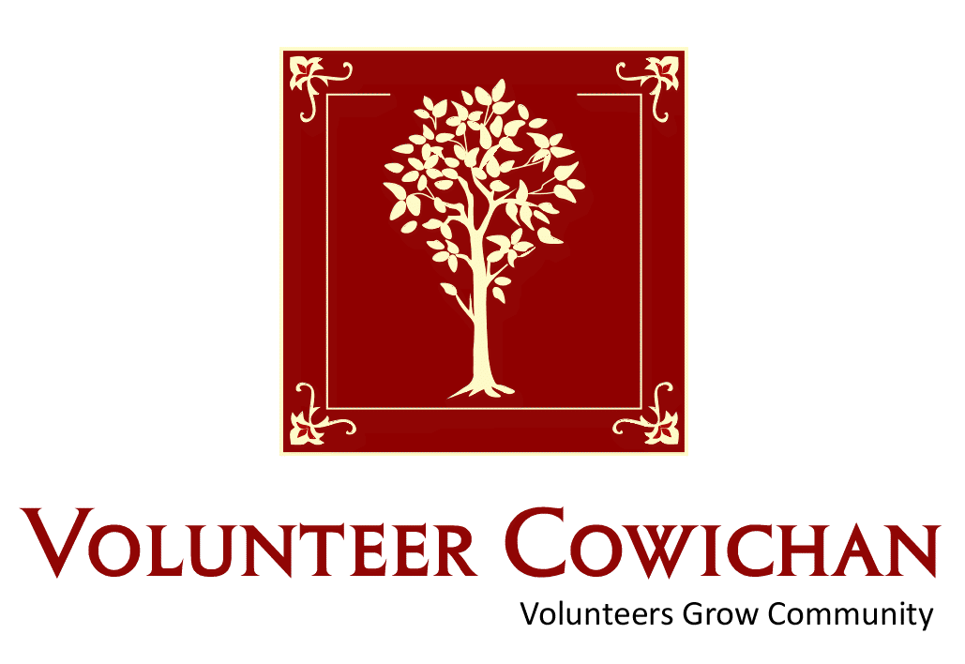**

Cowichan Volunteer &

Community Resources Fair

Find a Volunteer Opportunity &

Community Resource that’s right for you!

Duncan Mall

Saturday, April 5, 2014

10:00 am – 2:00 pm

Display booths, Connect with Valley Non Profits & Volunteer supported Organizations, Find out about Community Resources

available for Youth, Families & Seniors.

Cake, Door Prizes, & Helping Hands Volunteer Recognition @ 1pm

FOR MORE INFORMATION

PHONE: 250-748-2133 EMAIL: vc@volunteercowichan.bc.ca

[www.volunteercowichan.bc.ca](http://www.volunteercowichan.bc.ca)

**

Many thanks to all of our valued sponsors and supporters during

National Volunteer Week April 6-12, 2014

C:\Program Files (x86)\Microsoft Office\MEDIA\OFFICE12\Lines\BD14996_.gif

Do you have a resource, event or information you would like to share?

Send it to [cindylisecchn@shaw.ca](mailto:cindylisecchn@shaw.ca) and it will be included in the weekly Health Matters Newsletter