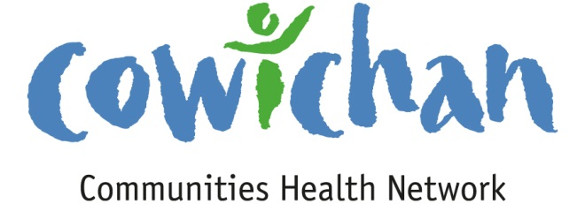

CHECK UP
March 15, 2013
Hello Everyone,
Don’t feel like a hike but want to clear your head on your lunch break? We have an amazing resource in our own back yard. Take 20 minutes to visit the Somenos Marsh Estuary walk. You will be happy you did and I can guarantee you will go back over and over again to see the changes throughout the seasons.

CCHN Network Member Meetings
Admin Committee Meeting- Wednesday March 20, 5:30 pm in CVRD Meeting Room 2
Upcoming Events/ Workshops/ Community Meetings
- Better at Home Community Meeting
March 20th from 12:00-3:00 at Duncan United Church (246 Ingram Street). PLEASE RSVP: 250-748-1312 or Email: office@cowichan.unitedway.ca ( Lunch Provided)
- Ladysmith Blood Donor Clinic
St. Mary's Catholic Church
1135 4th Avenue
Thursday, March 21st
12:30pm - 7:30pm
If you would like to donate as a group contact Chris at 250-729-3628 or email chris.barron@blood.ca
- Launch of Cultural Safety Video- Hul’qumi’num Health Hub
March 28, 2013 Island Savings Centre Theatre
Reception at 6:30 presentation at 7:00

Connecting the Dots..... As the facilitator goes out and engages in conversations or attends meetings in the community important information is learned along the way that may benefit or be of interest to Network Colleagues- A synopsis of conversations will now be shared in the connecting the dots section.

Demystifying Research Ethics Workshop-
March 8, 2013 Vancouver Island University
Helen Demers and Robin Julia Hood

Approximately 16 community individuals/organizations attended the session

The workshop provided information on the following:
Ensuring informed consent
Protecting those interviewed from harm
Respecting privacy, dignity and cultural practices
How to create research partnerships for community based research

- We looked at vulnerable populations and were provided with examples of vulnerability which included not only those who are cognitively impaired but children, youth, the homeless, those who have been traumatised and those who have mental health concerns.
- We discussed a code of ethics regarding undertaking research that is often attached to the institution or researchers professional affiliation.
- Do not hire researchers who are not experienced in the culture of the clientele
- We explored a variety of consent forms designed to meet the needs of those being interviewed
- Ensure that all information is returned to participants and that they are a part of the final product
- Ensure that reciprocity is undertaken especially in the case of gathering information from First Nations Elders- this should include an honorarium
- Always acknowledge participants’ contributions

Looking at partnerships:
- What groups are interested in looking collaboratively at a similar topic?
- What information would be valuable?
- What would be significant?
- VIU Offers FREE internships for students to engage in supporting local research! Contact the University to access student support
- We now have a fellow named Reid Early who is a well known demographer living in the Cowichan Region

Group discussion/ Potential Outcomes for CCHN:
- Idea of a community data base or one location to access local research- new and old. Possible website or community organization as the host
- Host a festival of research- bring institutions and organizations together for the day to talk about where we are in the Cowichan Region in regards to research and analysis of local data and where we want to go
- Build partnerships- who might be interested at collaborating?
  - Vancouver Island University
  - Social Planning Cowichan
  - Cowichan Communities Health Network
  - Cowichan Division of Family Practice
  - Cowichan Valley Regional District and Local Government
  - Cowichan Green Community
  - Volunteer Cowichan
  - Cowichan Tribes
  - Friendship Centre
  - Network For Families
  - Hul’qumi’num Health Hub
  - Cowichan Seniors
  - Ladysmith Health Network
  - Others?

Board Meets Board
March 12, 2013
New Life Baptist Church

Board Meets Boards is a gathering of Board Members, Executive Directors, Business and Government to come together to find a common ground. It provides training for boards of governors as well as links to like minded organizations.

Boards comes together to find patterns and opportunities to address the wellbeing of our communities. The social determinants of health play a significant role in educating the community how agencies have an impact not only on the economic well being of a community but also every resource and service provided.

Presentation:
Colleen McCormick- on Social Innovation.
Colleen spoke about the systems and complex problems that exist in our country. She also spoke about how society has two options to address these complex issues...1) It cannot be done so don’t even try or 2) How do we do it?

We need to decide- What kind of a community do we want to be a part of? In order to do so we need to bring on partners to affect change and to be successful. We cannot do this alone. The current system of silos does not encourage this kind of collaboration on complex issues. It is up to us to build our numbers, expand our conversations and to tackle problems with the determination of creating change if we all work together. Colleen provided a number of brilliant examples of how social innovation has resolved complex issues.

Co- Create →Co- Design→ Co- Exist

Outcomes for CCHN:
- To Collaborate with like minded organizations and institutions
- To be creative and innovative in our approach to complex issues
- To change the status quo and to question what works and what does not
- To provide opportunities for community to come together to have critical thinking conversations
- To support our Network with education opportunities
- To have the kind of network that wants to be there and believes that they can make a difference if given the opportunity to use their passions and skills
- By impacting policies, regulations, laws by changing culture, behaviours, language and assumptions because we have been able to converge different perspectives, ideas and processes.
- How to take a complex problem and look at it from 5 different perspectives – ( 6 hat Activity)

Municipal Alcohol Policy- new resource for communities

To view the guide, please visit:
www.health.gov.bc.ca/library/publications/2012/creating-municipal-alcohol-policy.pdf

For more information on BC Healthy Communities Municipal Alcohol Policy Program, visit: www.bchealthycommunities.ca/mapp

For more information on Healthy Minds, Healthy People, visit: www.health.gov.bc.ca/healthy-minds

For more information on creating healthy communities, visit: www.healthyfamiliesbc.ca

Calls for Proposals

Cowichan Valley
Thank you for your interest in contributing to the health of citizens living in the Cowichan Region. The Cowichan Communities Health Network (CCHN) is pleased to provide a maximum grant of $2,000.00 toward eligible projects in the Cowichan Valley. Please read the following information to ensure your proposal meets the funding requirements.

Focus of Funding:
The CCHN recognizes the health and well -being of our citizens is impacted by the social determinants of health within the context of healthy and supportive communities, organizations, families and relationships.

The CCHN has the opportunity to make a positive and meaningful contribution to our communities’ future. The CCHN is committed to helping the citizens of the Cowichan Communities enjoy good health.

Project focus:
Applications whose priorities for action are evidence based and focus on the determinants of health will be accepted for review.

Application templates are available on our website www.cchn.ca or contact Cindy Lise at cindylisecchn@shaw.ca . Applications will be accepted up to November 30, 2013 or until funds for the current year have been allocated.

- 1 copy must be submitted by email to: cindylisecchn@shaw.ca
- 1 hard copy must be mailed to:

Cowichan Communities Health Network
PO Box 20106
Duncan BC,
V9L- 5H1

Cowichan Communities Health Network

Application for Community Grant

Group Name/Organization__________________________________________________________________

Address_______________________________________________________________________________________

Phone_______________________________ Email Address________________________________________

Contact Person_____________________________________________________________________________

Amount of Dollars Requested___________________________

Number of recipients expected to benefit from project_______________________

Project Description- Maximum 400 words

What need (s) is being addressed?

How will you measure the impact of your project?

How does this project address the Social Determinants of Health?

Who are your community partners for the project?

Application must not exceed one typed page (size 11 fonts)

Applications must have financial statement attached

Maximum Grant Amount $2,000.000

Project proposals will be accepted until November 30, 2013 or until all funds have been allocated.

Cowichan Communities Health Network
PO Box 20106
Duncan BC,
V9L-5H1

Hul’qumi’num’ Health
With support from the
Coast Salish Employment & Training Society
Cordially invite you to the video premiere of
Tat ul utul’
“Getting to know each other”
A video project by the Hul’qumi’num’ cultural safety committee
that supports the delivery of culturally-safe healthcare at the Cowichan District Hospital and in the Hul’qumi’num territory.
Thursday, March 28, 2013
Cowichan Theatre, Island Savings Center
2687 James St, Duncan
Reception: 6:30 pm
Presentation: 7:00 pm
Please RSVP to Sharon Henry at (250)748-9760 or sharon.henry@cowichantribes.com
Funding Opportunity for New Approach to Healthy Living and Chronic Disease

Prevention Funding at the Public Health Agency of Canada: (see attached pdf for more information)
The Public Health Agency of Canada (the Agency) is launching a new process to engage Canadians in the development of project ideas that will help to prevent chronic disease and promote healthy living.
Complex public health challenges – like obesity –defy single solution approaches developed in isolation. We know that no single entity is responsible for any major health or social challenge, nor can any single organization effectively address it. What is required is that we explore new ways to unlock innovation through broad cross-sector engagement. By engaging multiple sectors of society, the Government and its partners can leverage knowledge, expertise, reach and resources, allowing each to do what it does best, in working towards the common shared goal of producing better health outcomes for Canadians.
Agency funding through Grants and Contributions promotes healthy living (i.e., physical activity, healthy weights, tobacco cessation) and chronic disease prevention (i.e., obesity, cancer, diabetes, cardiovascular disease) through an integrated approach that focuses on common risk factors. Funded projects will support the Agency’s contribution to Curbing Childhood Obesity: A Federal, Provincial and Territorial Framework for Action to Promote Healthy Weights and the Declaration on Prevention and Promotion, which presented a vision for working together, and with others, to make the promotion of health and the prevention of disease, disability and injury a priority for action.

Where you live may decide how soon you die
Groundbreaking study looks at life and death by neighbourhood
by Ken MacQueen on Sunday, March 3, 2013 6:00am - 8 Comments
VIEW IN CLEAN READING MODE »
WHAT IS THIS ?

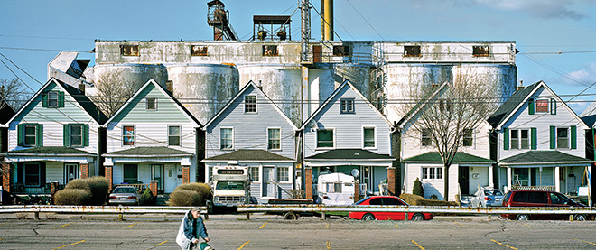
Stephen Brookbank
On March 6, Maclean’s hosts a town-hall discussion, “Health care in Canada: what makes us sick?” focusing on the social conditions that affect the health of Canadians, especially those in impoverished neighbourhoods. Held at the McIntyre Performing Arts Centre at Mohawk College in Hamilton, in conjunction with the Canadian Medical Association, it will also be broadcast on CPAC. The conversation about the health effects of disparities in income, education, housing and employment will continue in the coming months in the magazine, and at town halls in Charlottetown and Calgary.
What if you could see the future? What if you could see a young pregnant woman walking down Barton Street in Hamilton’s depressed north end and know her unborn child had already lost life’s lottery; that his or her fate was predetermined by Mom’s postal code?
You would know that this mother—in this neighbourhood, and in the bottom 20 per cent of the city’s income earners—is six times less likely than the wealthiest Hamiltonian to seek first-trimester prenatal care, and more than six times as likely to be a teenager or to have dropped out of school. You’d know the chances of her baby being born underweight and needing weeks in neonatal intensive care would also be higher.
And the child’s life would get no easier thereafter. If its parents lived an average life in this neighbourhood, they would die an average Third World death—at 65.5 years of age. If they lived five or six kilometres away, say, on Rice Avenue in the city’s leafy suburbs, they would live beyond 86 years.
What if you knew one of the world’s most advanced acute-care health facilities was here in Hamilton, yet was powerless to change the fate of this mother-to-be? What would you do?
What’s to be done is the challenge facing Hamilton and communities across Canada. The statistics are among the findings of Code Red, a groundbreaking analysis of life and death in 135 Hamilton neighbourhoods and census tracts. The multi-part series was written by Hamilton Spectator investigative reporter Steve Buist in collaboration with Neil Johnston, an epidemiologist and faculty member in McMaster University’s department of medicine.
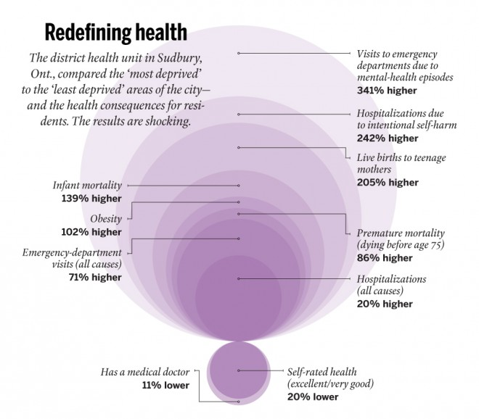The social determinants of health—income, housing, education, employment, early childhood development and race—divide us as certainly as any caste system. Where you sit on the income gradient sets your life course, determining how well you live and how soon you die. Divide Hamilton into income quintiles, and the average age of death for the wealthiest 20 per cent is 81.4 years. Death comes years earlier with each step down the income ladder. By the bottom rung, the poorest 20 per cent of Hamiltonians die at 69—12 years sooner.
Working on Code Red left Johnston feeling outraged at the waste of human potential, he said in a recent online presentation. He recalled how today’s hardest-hit inner-city neighbourhoods were thriving communities 40 years ago until the city was gutted by the decline of well-paying industrial, steel and manufacturing jobs, and by an exodus to the suburbs. “The chasm between neighbourhoods in the downtown core and the suburbs in determinants of health and health-service use is perhaps the single most important reason why Hamilton may never again be able to regain the relative prosperity it enjoyed 40 years ago,” he said.
The phenomenon isn’t unique to Hamilton. The district health unit in Sudbury, Ont., is a strong advocate for redefining what makes us healthy, and has compared the “most deprived” and “least deprived” areas of that city. Among the most deprived: births to teenage mothers were 205 per cent higher; infant mortality, 139 per cent higher; and premature death, 86 per cent higher. The health region in Saskatoon also looked at health disparities in their city. In six low-income neighbourhoods, rates of infant mortality were 448 per cent higher; teen births, 1,549 per cent higher; and suicide attempts, 1,458 higher. “Moral reasons aside, it is in our collective interest to reduce social disparity,” the health region concluded.
Focusing on non-medical social problems is a priority for the Canadian Medical Association (CMA), which advocates for a sustainable, equitable and more effective health care system. Health is more affected by socio-economic factors than by doctors, drugs and hospitals, CMA president Anna Reid, an emergency room doctor in Yellowknife, said in an interview. “We feel we have a responsibility—a duty, actually—to start advocating for policies that change people’s life circumstances.”
If society must be fixed in order to heal the individual, where does one begin? Reid concedes doctors don’t have the answers. “We’re not the experts on how to fix the housing crisis, [although] we certainly are the experts on seeing the downstream effects of people who have no housing,” she said. “We don’t know how to fix the education system, but we know that if you don’t have an education, this is what it’s going to do to your health.”
Studies find the problem is a lack of accountability and inadequate budgeting for such necessities as housing, education, social services, child care, policing and other non-health determinants, which rest with different levels of government, each responsible for one puzzle piece that rarely fits into a complete picture. Experts say it’s a jurisdictional nightmare and an excuse for inaction.
Dennis Raphael, a professor of health policy at Toronto’s York University, has written extensively on Canada’s missed opportunities and the false economy of neglecting the web of social determinants. Canadians are among the world’s leading researchers on issues such as the health effects of poverty on early childhood development, but the results are more likely to be implemented in Scandinavia and European countries like France and Germany, where the concept of a welfare state is not dismissed out of hand, Raphael says.
While Canada spends heavily on a health care system designed to fix the sick, it’s a middling performer among fellow wealthy nations in health outcomes and in value for money spent, according to a much-ignored 2009 Senate report, A healthy, productive Canada: a determinant of health approach. Fully 75 per cent of factors influencing health rest outside the health care system, it found. “Passively waiting for illness and disease to occur and then trying to cope with it through the health care delivery system is simply not an option.”
Sudbury’s is among the health units working to shift government priorities. It produced a short video, Let’s start a conversation about health . . . and not talk about health care, which has been picked up and modified by health authorities across Canada, says the unit’s Stephanie Lefebvre. As manager of health equity, one of Lefebvre’s roles is to bridge the divide among a range of services and to ensure that the potential health impacts of local initiatives are considered in advance.
In Hamilton, Code Red has inspired changes including implementation of a nurse-family partnership program to guide high-risk mothers, and incorporation of the implications of social determinants into McMaster University curriculums for health professionals. It influenced McMaster’s decision to build its new $86-million health campus in the inner city, where it will provide primary care to an underserved population and give medical students an understanding of the challenges residents face.
Mark Chamberlain, a successful Hamilton businessman and a member of the city’s round table on poverty reduction, knows many people who live in the city’s blighted neighbourhoods. “They’re fantastic people, but their health outcomes aren’t determined by how fantastic they are and how much they volunteer,” he says. “Once they know where a baby is born from a postal code perspective—based on not changing our scenarios in how we invest—they can pretty much predict the outcome of that child, when and how they’re going to die.”
It’s a glimpse of a future he can’t accept, and one he’d like to think there is growing determination to change.
The Hamilton town hall will be moderated by Maclean’s Ken MacQueen, with opening remarks by Dr. Anna Reid, CMA president. The panel features Debbie Sheehan, former director of Hamilton’s family health division; Dr. Dale Guenter, department of family medicine, McMaster University; Mark Chamberlain, member of the Hamilton round table for poverty reduction; and John Geddes, Maclean’s Ottawa bureau chief.

