

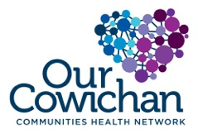

**Health Matters Newsletter**

**June 13, 2014**

**Today’s Health Matters Includes:**

**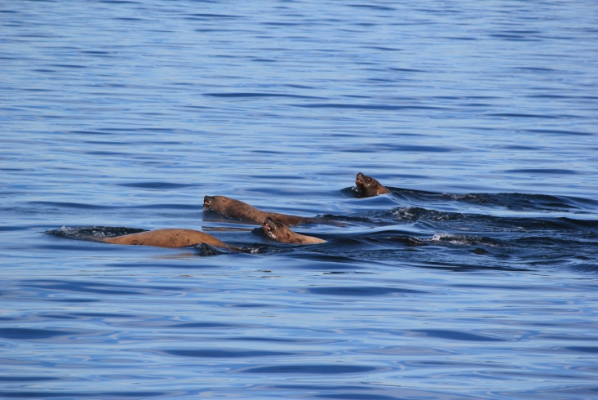**

* Meeting Schedules
* Community Meetings and Events
* Our Cowichan Small Grants Available
* NDP Supports Call for Ban on Flavoured Tobacco Products
* United Way Stronger Communities Forum in Vancouver
* Collective Impact Summit

An evening kayak out of Cowichan Bay may introduce you to some new friends!

C:\Program Files (x86)\Microsoft Office\MEDIA\OFFICE12\Lines\BD14996_.gif

**Our Cowichan- Network Member Meetings-**

* **Next Our Cowichan Network Meeting –Thursday July 10,** CVRD Board Room. Light dinner at 5:30 pm – Meeting starts at 6:00 pm
* **Next Admin Committee Meeting-** Wednesday June 18, 5:00 pm CVRD Committee Room 2
* **Next Communications Committee Meeting-** Wednesday June 25, 9:00 am CVRD Room to be announced
* **Next Grant Committee Meeting-** Wednesday October 1, 9 am to 11 am CVRD – Room to be announced

C:\Program Files (x86)\Microsoft Office\MEDIA\OFFICE12\Lines\BD14996_.gif

**Upcoming Events/ Workshops/ Community Meetings**

* Be a Tourist in your own hometown this summer- check out the Events Calendar for the Cowichan Valley for dates, locations and times for many community events, festivals and activities!
* On June 21st, Canadians from all walks of life are invited to participate in the many National Aboriginal Day events that will be taking place from coast to coast to coast. This is a special day to celebrate the unique heritage, diverse cultures and outstanding achievements of First Nations, Inuit and Métis peoples in Canada. [Learn about](https://www.aadnc-aandc.gc.ca/eng/1100100013718/1100100013719) Governor General's Proclamation.
* National Aboriginal Day on June 21 kick starts Celebrate Canada!, an 11 day celebration that also includes Saint-Jean-Baptiste Day (June 24), Canadian Multiculturalism Day (June 27) and concludes with Canada Day (July 1)!

C:\Program Files (x86)\Microsoft Office\MEDIA\OFFICE12\Lines\BD14996_.gif

**NDP bill supports call for ban on flavoured tobacco products**  
   
(First Call) June 10, BC youth and NDP health critic Judy Darcy called on the Liberal government to ban the sale of flavoured tobacco in BC, according to a [news release](http://cts.vresp.com/c/?FirstCallBCChildandY/582390bd3a/321050fb30/363c90ab11). This follows [Darcy’s introduction](http://cts.vresp.com/c/?FirstCallBCChildandY/582390bd3a/321050fb30/52e160d3b6) of the [Tobacco Control Amendment Act](http://cts.vresp.com/c/?FirstCallBCChildandY/582390bd3a/321050fb30/bcb763529b) in the legislature in April 2014.  
   
First Call is committed to working to protect BC’s youth in the face of evidence of harm from tobacco use and their vulnerability to youth-focused marketing and supports a ban of these products.  
  
Find out how you can [take action](http://cts.vresp.com/c/?FirstCallBCChildandY/582390bd3a/321050fb30/7ca6c1ed3b) through a campaign lead by the Canadian Cancer Society.  
Find background information on the webpage, [Candy or Cancer?](http://cts.vresp.com/c/?FirstCallBCChildandY/582390bd3a/321050fb30/81546480a4)

C:\Program Files (x86)\Microsoft Office\MEDIA\OFFICE12\Lines\BD14996_.gif

**Notice of the Annual General Meeting of Volunteer Cowichan**

June 20, 2014; 3:30 pm

at 1 Kenneth Place (lower level of Duncan City Hall), Duncan

Volunteering is a fundamental act of citizenship and philanthropy in our society. It is offering time, energy, and skill of one's own free will. Volunteers impact virtually every aspect of society including health, education, social services, youth, sports and            recreation, culture, the arts and the environment.  
  
Volunteer Cowichan raises awareness of the power of service, encourages people to volunteer, provides information about volunteerism and recognizes the contribution of volunteers.  
  
Please RSVP at 250.748.2133

C:\Program Files (x86)\Microsoft Office\MEDIA\OFFICE12\Lines\BD14996_.gif

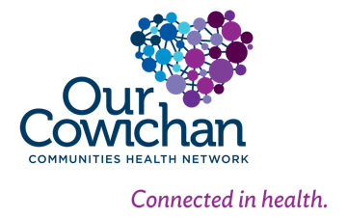

Calls for Proposals

Cowichan Valley

C:\Program Files (x86)\Microsoft Office\MEDIA\OFFICE12\Lines\BD14800_.gifThank you for your interest in contributing to the health of citizens living in the Cowichan Region. Our Cowichan Communities Health Network (OCCHN) is pleased to provide a maximum grant of $2,000.00 toward eligible projects in the Cowichan Valley. Please read the following information to ensure your proposal meets the funding requirements.

Our Cowichan recognizes the health and well -being of our citizens is impacted by the 12 Key determinants of health within the context of healthy and supportive communities, organizations, families and relationships.

Our Cowichan has the opportunity to make a positive and meaningful contribution to our communities’ future. OCCHN is committed to helping all citizens of the Cowichan Communities enjoy good health.

**Project focus:**

Applications whose priorities for action respond to demonstrated community needs, gaps and priorities and that are evidence based and focus on the determinants of health will be accepted for review.

Application templates are available on our website [www.cchn.ca](http://www.cchn.ca) or contact Cindy Lise at [cindylisecchn@shaw.ca](mailto:cindylisecchn@shaw.ca) . Applications will be accepted up to October 1, 2014. Funding announcements will be made by October 15, 2014 or sooner.

* 1 copy must be submitted by email to: cindylisecchn@shaw.ca
* 1 hard copy must be mailed to:

Our Cowichan

PO Box 20106

Duncan BC,

V9L- 5H1

C:\Program Files (x86)\Microsoft Office\MEDIA\OFFICE12\Lines\BD14996_.gif

**What makes a community healthy and livable for all?  
How do we work together to help our most vulnerable?**  
  
Join us for **United Way’s Stronger Communities Forum & 2013/14 Annual General Meeting**  
to explore the concepts of social determinants of health and community social planning.  
Hear best practices from guest speakers and share your own. Discuss ideas on how to promote population health and community well-being.  
  
**Keynote speaker:**  
Ted Bruce, Health Policy Consultant in Population Health and Primary Care, and **new Interim Director of the Portland Hotel Society**.  
*“Building healthier communities - How can we find our way?”*  
  
Wednesday, June 25  
Registration: 10:30 am  
Forum and AGM: 11:00 am to 6:00 pm  
Hilton Vancouver Metrotown 6083 McKay Avenue Burnaby, BC  
  
[Register now](http://link.scsend.com/mdSs?recipient_id=14kVdhShd71tHCXikVVf5gyLbK6lNFg_Zg). Please share with others!

C:\Program Files (x86)\Microsoft Office\MEDIA\OFFICE12\Lines\BD14996_.gif

**Collective Impact Summit**

Is your organization looking to change your community? Are you trying to bring together teams but are constantly frustrated by the outcomes and are looking for a better way? Collective Impact is a proven approach for making large-scale change possible. The first-ever [Collective Impact Summit](http://events.tamarackcommunity.org/e1t/c/*W8PNvmm6K9l5nW2d79JB7mTLnK0/*W2m_Zjq72Zyt8W94-QXP5f9Rgl0/5/f18dQhb0S66X6Xx2d0SmLH60FHYvW1KlWdd5z75dPN1z0XsTNFJSBW3BGc5g7J_lkzW2D29FC3sxNY_W5LwpKH6ZYrC4W8zq63z4NBg63W4znP1r81SHp1W7HdRTr7z0hb-W8v8_5z4q2XnQW2rxkF22-9M7GVNN1wQ4HC-bnN1flRkN8y3C1W5DsRCH7f2FdvN6kGkyFDGZGRW576DG81T9wGdW3-7YXz2zzGZxW7x404C7PXw33W5W5plJ7nBG7kVYDjb248WFR-Vp6-9w6kbwfHW5phPHg33TTq4W5wlBTN681Fj7W8Xw0LR8ZKQshW1ql6Dv1fkdLwVJk4z05ggKB9W5rXNJ16qjCm4W3r616Y4jm02MW8G2ykf6XtCS8W5CmS1n7wsP-7W1FR4SX1Fl9LxW8L_hpQ8J7x2YW99-WWG3Ls2RGW7Bt-B_5qDSpfW2gxn933d8K9hW29hP4P7YlWMgW3K1MRN6FxxvrW52cfMz3vJ_Rt111) is happening this October and you are invited. [**Learn more here.**](http://events.tamarackcommunity.org/e1t/c/*W8PNvmm6K9l5nW2d79JB7mTLnK0/*W82gqRt6-VZJ0W2NLXzf7rqTf90/5/f18dQhb0S66X6Xx2d0SmMg60FHYvW1KlWdd5z3L9tW6jv3401dg55DVQYnXP1Y7qCDW7W67m64tggRhW8cPW5_8R2BZYN3cnz47Ch9TBW8pNY_16W8g4TW5L1pQg8MN-CWW37cHNy64tkVwW5yVYbg3Ky8qJW1ClpDH5w0D0fN463Cb2MMRFyW5KTP4_663LB2W5_XNc_6GDVK2W6NP50q3kSgdsW7Gx_Rq2sYQH3W2pF59g8H1f-XW70TPmB2ltcWJW5R5lMr53NYhKW1x3Cyj5Gw5R3W58wJrQ2Tl7FmW3xTxyz8CBgDcN7BrmdQkxxlDW3MlVxW5QB8TfW6v9LyQ86Lx3gW3xMGS98JPJ_1W94RRPp3H-b7lW289dZ975HW8rW4-Kk934t5FsDW97WgZr16T0h-W4LRTdP91cDqnW5FpSDc552rx2W7k-r5P1MnYpNW59vhw92g52VzW6KP8cW7fvjcPW6ZLhjH66WTZ4W8R92dy54bz48f2QYvdW04)

The successful implementation of Collective Impact requires funders to think differently, community leaders to simultaneously collaborate while they compete, and business and government leaders to apply their skills and power to advance the work of community change.

The Summit is a week-long gathering where:

* World-renowned speakers will share their latest thinking;
* Communities who are working on similar issues will learn from each other; and,
* We’ll put our minds together to refine and operationalize Collective Impact as a practice that requires us to think differently and work differently to address our most complex issues.

This gathering will provide you with the opportunity to take your understanding of collective impact even further. Joining us to advance our shared understanding of this emerging field will be Melody Barnes, John Kania, Fay Hanleybrown, Jay Connor, and Liz Weaver.

Learn more about the Collective Impact Summit including the agenda, speakers and logistics on the [Summit event page](http://events.tamarackcommunity.org/e1t/c/*W8PNvmm6K9l5nW2d79JB7mTLnK0/*W7Wkz_P54wqcSW8R7nX82xph940/5/f18dQhb0S66X6Xx2d0SmLH60FHYvW1KlYgK3D-tQBW304n6C38XHTRW19rKnX5GCR2KW1CjsSn868JGpW23YQD64xPVhbN7QHWMX845SyW96Nf996KRQ4QW5pHpbr6Yh-7mW3t5qw-5YlXQ4W2Mjq4d3_LcgjW4TLG6Z11nbkZW6M21HH2nD_6vW1F0JmQ2M6tHfN3rL7drLZFzmN4MF0_k8bqD6W3m2G2l6fQMLBW5BmVv965Y_QmW2w69794-lzfqVXRNlq2x7hZ2W1vF-1430hcPSW4_cP334-SV9wVvCDFL8Tp8MsW9br9YY77PmhbW4CZvdZ6qC_1BW4TQFz_8Z25xyN6V75R9SlwNnV7GRRb2LMHd9W4fTMbV4rG_MVW77ctN-17DdK5W8ZFXPh23W6XXW4zQnXd6vHyFzW7g3W_f6qYWm7N2xxgVsrt04hW2tLGJc7TYPJgW5Wgv_p4r5hz6W7_lWW66p1__dW1X4CW_3vnFyRf4yh2v403).

C:\Program Files (x86)\Microsoft Office\MEDIA\OFFICE12\Lines\BD14996_.gif

C:\Program Files (x86)\Microsoft Office\MEDIA\OFFICE12\Lines\BD14996_.gif

Do you have a resource, event or information you would like to share?

Send it to [cindylisecchn@shaw.ca](mailto:cindylisecchn@shaw.ca) and it will be included in the weekly Health Matters Newsletter