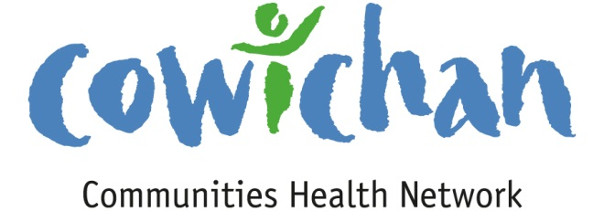

CHECK UP
July 26th, 2013
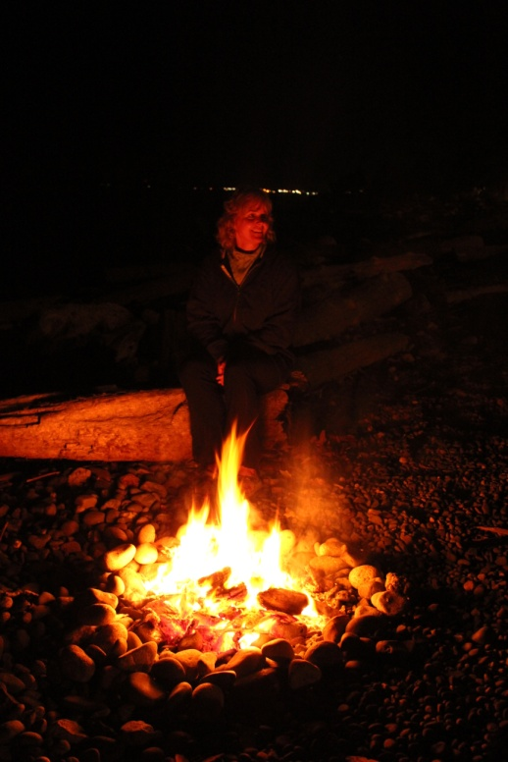
The best reality television ever.... it comes with great stories, comedy, music and more.... One should really give it a try!

Today’s Check up Includes:

- Meeting Schedules
- Community meetings and events
- 2014 Federal Budget Submissions- Form included
- Social Enterprise World Forum Calgary Oct 2-4
- New Healthy Eating Tool Box
- Underlying Premise Evidence- (part 2) Social Support
Networks
- United Way Public Policy Institute - application

CCHN Network Member Meetings-
- None scheduled for this week
Upcoming Events/ Workshops/ Community Meetings
- WANTED MEETING ROOM…I am looking to start a new support group for people with early dementia that will meet twice a month. Do any of you have any ideas about meeting spaces in Duncan. Free is always best, but we do have a small budget for support group rooms. If you are able to assist or know of a location that might suit our needs please contact Jane Hope at jhope@alzheimerbc.org
2014 Federal Budget Submissions
Now is the time to submit a recommendation to the House of Commons Standing Committee on Finance as a part of the annual pre-budget consultation process.
Any individual or organization may submit up to three recommendations using this template. The submission deadline is August 5, 2013. More information including the news release, an example of a completed template, and a list of priority areas can be found here.
Social Enterprise World Forum 2013
c/o MCI Vancouver
October 2-4, 2013
Telus Convention Centre
Calgary, Alberta, Canada
Click Here to View the Forum Website
The 2013 Social Enterprise World Forum (SEWF) will bring together 1,200 individuals from more than 30 countries and speakers from more than 20 countries. Attendees will come from diverse backgrounds – social enterprise practitioners from all sectors, traditional non-profits, for-profit businesses, philanthropists, intrapreneurs, the public sector, support agencies, funders and investors, consultants, indigenous groups, and students – but all share a dedication to resolving the world’s most complex and confounding social challenges.

Accommodations
Don’t forget to make your hotel reservations for your stay in Calgary today! Book now to take advantage of the hotel rates offered to the SEWF2013 Forum by booking at one of the official hotels. You can make your hotel reservation at any time by going to the Book Your Accommodation icon in your email confirmation or by going to the Accommodation page on the forum website.
We would like to request your assistance and support of SEWF2013 by booking your accommodations exclusively at the Forum hotels. The official Forum hotels were chosen for the numerous benefits they offered the Forum as well as the attendees. Your loyalty and co-operation are greatly appreciated.
If you require a visa to enter Canada, please visit http://www.cic.gc.ca/english/visit/business.asp for updated visa requirements. If necessary, the SEWF2013 can forward information, but can only do so AFTER full payment of registration.
Looking for more information? Check out http://www.sewf2013.com
We look forward to seeing you in Calgary!

Health Canada updates new healthy eating toolbox
Health Canada has a new Healthy Eating Toolbox with helpful resources for consumers and professionals. This online resource has been updated with a new set of fact sheets, including focus-tested messages for planning at home and at the grocery store, as well as a new Eat Well web banner, print public service announcement and short video clip to share and use.
The toolbox contains:
- Resources to share with Consumers – includes fact sheets on sodium, meal planning, and nutrition labelling; interactive tools; and other resources.
- Resources for Health Professional and Educators – includes various resources and ready-to-use presentations on a variety of topics.
- Marketing and Media Outreach – includes a button, videos, banners, and posters that can be embedded on websites. The button directs visitors to Health Canada Eat Well.
To stay up-to-date on food and nutrition web postings and publications subscribe to the Food and Nutrition RSS feed here.

Public Health Agency of Canada -Underlying Premise and Evidence Table – (two of a series of 12)
Conference on building resiliency & hope when working with native youth and families, with Dr. Martin Brokenleg

July 24, 2013, Italian Cultural Centre, Trattoria Ballroom, 3075 Slocan Street, Vancouver
Dr. Martin Brokenleg consults worldwide and serves as a Vice President of Reclaiming Youth International, providing training for individuals who work with youth at risk. This event is hosted by the Urban Native Youth Association and Coming Home Society. All funds raised will help fund the YWL Transition Worker who provides intensive one-year support to young women who have graduated from their four-month live-in program helping youth to maintain sobriety, find safe housing, and support healthy relationships.
Registration cost: $150
For more information and to register contact Urban Native Youth Association at 604-254-7732, or email info@unya.bc.ca

KEY DETERMINANT -- 2. Social Support Networks
UNDERLYING PREMISES
EVIDENCE
Support from families, friends and communities is associated with better health. Such social support networks could be very important in helping people solve problems and deal with adversity, as well as in maintaining a sense of mastery and control over life circumstances.
The caring and respect that occurs in social relationships, and the resulting sense of satisfaction and well-being, seem to act as a buffer against health problems.
In the 199697 National Population Health Survey (NPHS), more than four out of five Canadians reported that they had someone to confide in, someone they could count on in a crisis, someone they could count on for advice and someone who makes them feel loved and cared for. Similarly, in the 199495 National Longitudinal Survey of Children and Youth, children aged 10 and 11 reported a strong tendency toward positive social behaviour and caring for others.
Evidence from Investing in the Health of Canadians:
Some experts in the field have concluded that the health effect of social relationships may be as important as established risk factors such as smoking, physical activity, obesity and high blood pressure.
- An extensive study in California found that, for men and women, the more social contacts people have, the lower their premature death rates.
- Another U.S. study found that low availability of emotional support and low social participation were associated with all-cause mortality.
- The risk of angina pectoris decreased with increasing levels of emotional support in a study of male Israeli civil servants.
Apply for the 2014 United Way Public Policy Institute
Program runs January to June, 2014. Application deadline is October 11, 2013 (Space is limited so those interested are encouraged to apply early)
This program is specifically designed to help non-profit leaders and their organizations increase their knowledge of the public policy process and their capacity to influence it. Monthly two-day sessions will be delivered over a six month period; from January to June 2014. The program provides participants with the opportunity for shared learning as part of a small cohort of 25 sector leaders, and an applied learning approach with a manageable course calendar make this a unique capacity building opportunity.
Organizations applying to attend this training program must be from the non-profit sector, active in the areas of social or health-related services and interested in affecting public policy change in those areas. Enrolment is open to organizations from all regions of the province.
For more information or to apply visit www.uwlm.ca/public-policy-institute, or contact Yves Trudel at ppi@uwlm.ca

Do you have a resource, event or information you would like to share?
Send it to cindylisecchn@shaw.ca and it will be included in the weekly
Check UP Newsletter.

