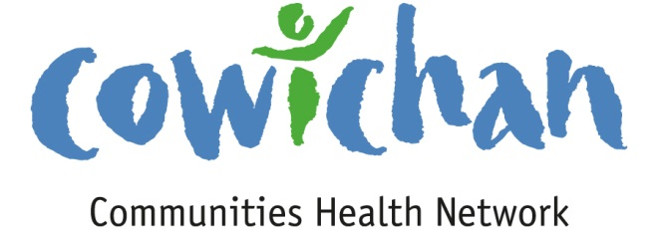

CHECK UP
July 12th, 2013
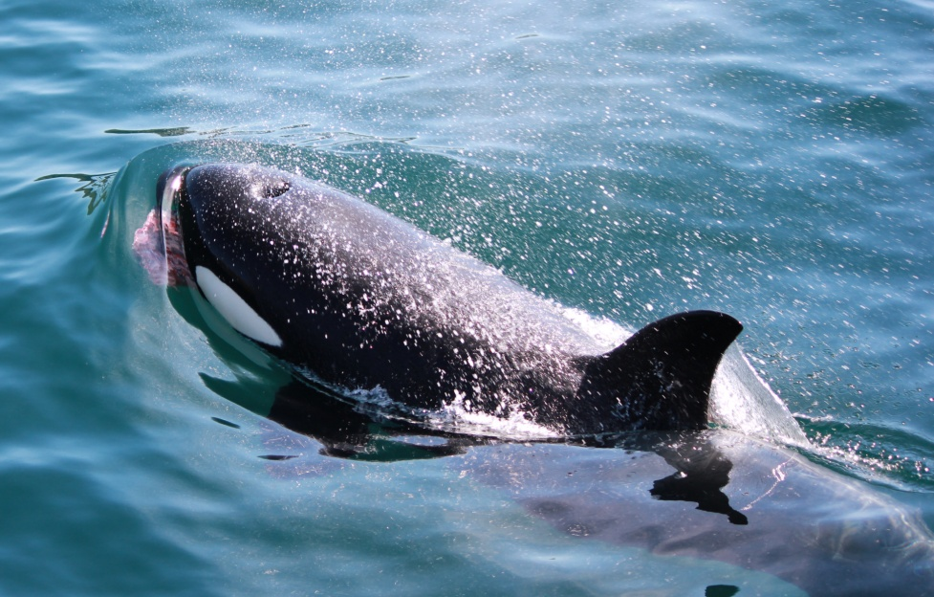
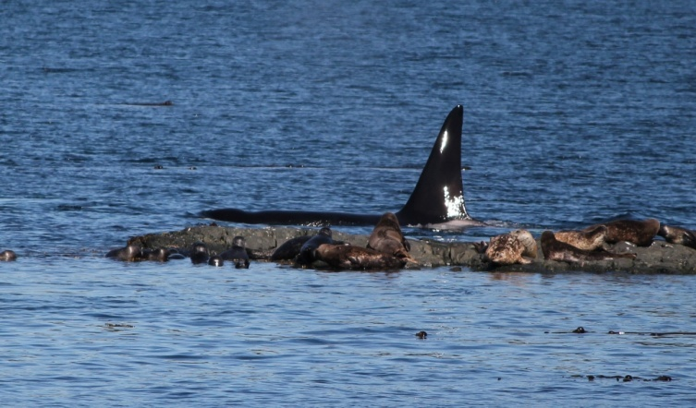
July is Whale Watching Time.. This whale was one of three transient whales I got to watch hunting seals off of the rocks near Telegraph Cove..(A very rare and spectacular sight)!... You can see that it was successful in its hunt! If you have the opportunity to take a whale watching tour you will be reminded of how important it is for us to protect our waters and the magnificent creatures that make the ocean their home. Our environment is important to the health and wellbeing of humans, mammals, animals, birds, fish and reptiles....
(NOTE... there was a super pod of 82 followed out of Cowichan Bay THIS WEEK)!

Today’s Check up Includes:
- Meeting Schedules
- Community meetings and events
- UN Declaration of Rights for Indigenous Peoples
- Cultural Competency On Line Training

CCHN Network Member Meetings-
Strategic Planning Session (CCHN members only) Wednesday July 17, 4:00 pm to 8:00 pm –Taiji Group-
1145 Maple Bay Road (Dinner Provided)

Upcoming Events/ Workshops/ Community Meetings
- Success by 6, Coastal Community Credit Union and Modern Windows present “THE CROODS” MOVIE NIGHT in the PARK at the Cowichan Sportsplex Saturday July 12th Movie starts at Dusk (9:15 ish).... The Event is free but donations are welcome to support programs for children within the region.

- Crofton Movies In The Park- July 20th, August 10th, August 24th, September 7th – 9:00 pm Crofton Old School Museum Park by the Salt Spring Ferry- Its back! The fun free summertime event for families of all ages... Movies in the Park will feature a selection of family friendly films like Indiana Jones, How to Train your dragon and We Bought a Zoo. For a full list see our poster. Every second Saturday starting the end of June until the first week of September. No cost, by donation with proceeds going to a new Skate park for Crofton. Concession available. Start time is approx 9pm for all showings (dusk). Bring a blanket or something comfy to sit on and enjoy!

- Ladysmith Resources Centre Concerts in the Park- July 7, July 14, July 21, July 28, August 11, August 18, August 25th – 6:00 pm in the Amphitheatre at Transfer Beach Concerts in the Park! Volunteer driven and at the Amphitheatre at Transfer Beach Park. Performers are enlisted for eight – 2 hour Sunday evening concerts. People enjoy an evening of song, while watching boats sail by, seals playing near the shore, and enjoying the early evening breezes off the ocean while having their picnic dinner

The UN Declaration on the Rights of Indigenous Peoples
- UNICEF has produced a publication explaining how the Canadian government can be more effective in protecting the rights of Indigenous people. "Know Your Rights" has a particular focus on young people and is a worthwhile guide to share with youth and adults.
View the publication here.
See the press release.

Social Determinants of Health | Canadian Best Practices Portal
If you are looking for some great information and researched topics related to the social determinants of health this website is a great place to start. This site includes data and best practices on public health topics
cbpp-pcpe.phac-aspc.gc.ca › Public Health Topics‎

Cultural Competency Training- On line Training Program

This training course increases Aboriginal-specific knowledge, enhances individual self-awareness, and strengthens skills for professionals working directly or indirectly with Indigenous people. Relevant for those working in the area of justice, policing, child and family services, education, business, and government. Learn about Core ICC Training at http://www.culturalcompetency.ca/
To view more professional development opportunities, visit the UFV Centre for Safe Schools and Communities website.
Do you have a resource, event or information you would like to share?
Send it to cindylisecchn@shaw.ca and it will be included in the weekly
Check UP Newsletter.

