

**Health Matters**

**January 31, 2014**

**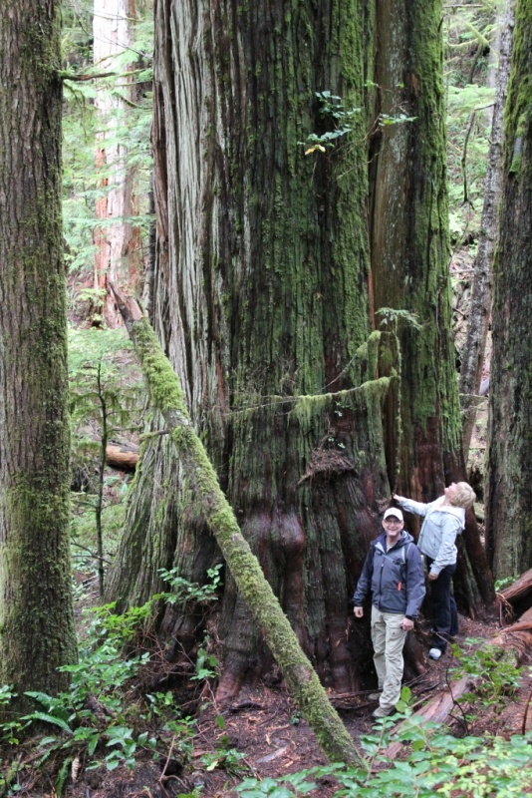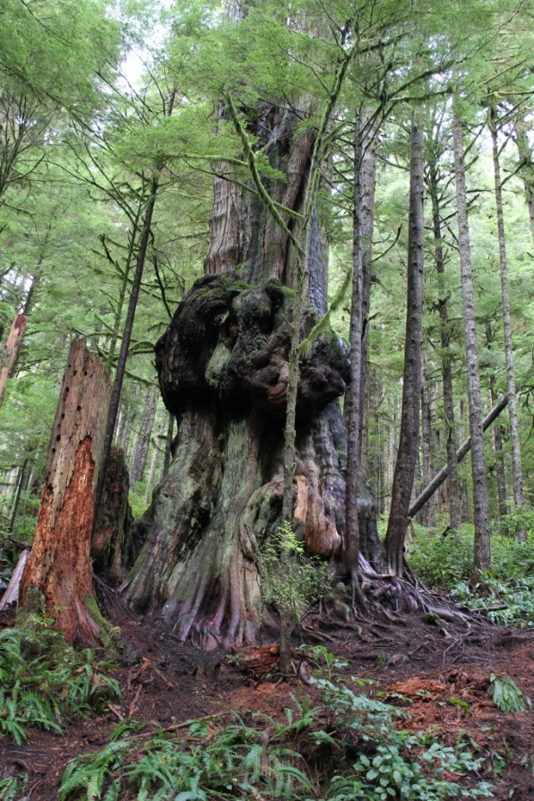**

If you have never been to Avetar Grove you must check out the world’s largest gnarly tree! This giant, (and many more), are just outside of Port Renfrew.

**Today’s Check up Includes:**

* Meeting Schedules
* Community meetings and Events
* BC Teens want Fruit Flavoured Tobacco Ban
* Cowichan Homeless Count- call for volunteers
* Mount Prevost Awarded Aviva Grant of $125,000.00!
* Gathering of Change Makers Community – Conversation
* Volunteers needed for Walk of the Nation

C:\Program Files (x86)\Microsoft Office\MEDIA\OFFICE12\Lines\BD14996_.gif

**CCHN Network Member Meetings-**

* **Grant Committee Meeting** Thursday February 6, 10 am, CVRD Committee Room 1
* **Next Our Cowichan Network Meeting –** Thursday February 13, 6:00 pm CVRD Board Room. Light meal at 5:30
* **Next Admin Committee Meeting** Wednesday February 19- 5:30 Committee Room 2 CVRD

C:\Program Files (x86)\Microsoft Office\MEDIA\OFFICE12\Lines\BD14996_.gif

**Upcoming Events/ Workshops/ Community Meetings**

**http://www.cdc.gov/nccdphp/dch/programs/healthycommunitiesprogram/tools/pdf/SDOH-workbook.pdf**

**Ready To Rent Classes**

12 hour course over 6 weeks to support you to find and keep better housing

• Identify what landlords look for in choosing a tenant

• Learn some strategies to find the housing you need

• Figure out how to improve your rental references and your credit rating

• Learn your rights as renter.

**Are you Ready to Rent?**

**Direct Benefit: This course is viewed by some landlords as being like a letter of Reference**

**Literacy Cowichan**

213B 80 Station Street, Duncan

Classes are from 10:00 am to 12:00 pm every Thursday for six weeks

Feb 13th to March 20th, 2013

Please register with Kathleen at - 250-597-1776

**Classes will be offered at Ladysmith Resource Center**

630 – 2nd Avenue, Ladysmith

Classes are from 2:00 pm to 4:00 pm every Monday for six weeks

Feb 17th to March 24th, 2013

Please register with Cindy at 250-245-3079

**Cowichan Lake Community Services**

121 Point Ideal Rd.

Classes are from 10:30 am to 12:30 pm every Monday for six weeks

Feb 17th to March 24th, 2013

Please register at Community Services – 250-749-6822

C:\Program Files (x86)\Microsoft Office\MEDIA\OFFICE12\Lines\BD14996_.gif

**BC teens want ban on fruit and candy flavoured tobacco**  
   
In a poll of more than 1,100 teens and adults, recently released by the Canadian Cancer Society, BC and Yukon, 81% of BC teens ages 15 to 18 and 74% of people over 18 support a ban of all fruit- and candy-flavoured tobacco products.  
   
The Canadian Cancer Society is [calling for a ban](http://cts.vresp.com/c/?FirstCallBCChildandY/622f127bbf/321050fb30/f6eddb68d1/region=bc) of these products. “We are urging the BC government to protect children from the predatory marketing practices of the tobacco industry and the products, which, through their packaging and appearance, are aggressively targeted to youth,” said Kathryn Seely, director of public issues.  
   
First Call is committed to working to protect BC’s youth in the face of evidence of harm from tobacco use and their vulnerability to youth-focused marketing. We support the Canadian Cancer Society’s call for a ban of these products. You can help by sending this message, “I support legislation to ban all fruit- and candy-flavoured tobacco products,” to Health Minister Terry Lake [hlth.minister@gov.bc.ca](mailto:hlth.minister@gov.bc.ca) and Premier Christy Clark [premier@gov.bc.ca](mailto:premier@gov.bc.ca)  
   
Watch the Global News clip [here](http://cts.vresp.com/c/?FirstCallBCChildandY/622f127bbf/321050fb30/b65e641f99)

C:\Program Files (x86)\Microsoft Office\MEDIA\OFFICE12\Lines\BD14996_.gif



**Cowichan Homelessness Count**

**Call for Volunteers**

Social Planning Cowichan is seeking volunteers who are interested and available to help carry out a Cowichan regional homelessness count on Feb 17-18th, 2014.

The results of the homelessness count will be used by service providers, advocates, citizens and governments to tackle issues related to homelessness. Count results will provide an estimate of the size of the homeless population and a current profile of homelessness in the Cowichan.

Homelessness counts have become increasingly widespread as communities work to increase awareness of and validate further action to reduce homelessness. Count data is used in policy development, planning, and prioritizing services to address the needs of people who are homeless. Homelessness counts present not only an estimate of the number of homeless people in a region, but also insight into the local factors contributing to homelessness and the resources needed to assist people to transition from being homeless to being independently, safely and securely housed.

The volunteer commitment required for the count will be for attendance at a 2.5 hour training event in the weeks prior to the count, and a 4 hour shift on the evening of Feb 17 or during the day on Feb 18th. We are looking for volunteers with the following characteristics:

* good people skills,
* an interest in social issues,
* respectful demeanour,
* ability to read non-verbal cues,
* some familiarity with the geographic layout of the area,
* a sense of humour

If you think this describes you, and you’re willing and able to help with the homelessness count, please fill out the attached volunteer form and send it to researcher Greg Awai at [greg@blacktomato.ca](mailto:greg@blacktomato.ca). Greg can also be reached by phone at 250.510.3574

**C:\Program Files (x86)\Microsoft Office\MEDIA\OFFICE12\Lines\BD14996_.gif**

**We're Aviva Community Fund Grand Prize Winners!**

They liked our idea so much they awarded us **$125,000** for our multi-generational community playground!!

One of the top prizes!!!

**WOW.**

Over 1000 applications were received Canada-wide.  And in the end they chose us.  “Little old Duncan”.  Gotta love team.

**AND WHAT A TEAM:  we couldn't have done it without you!**

Our heartfelt thanks go out to you all.  Thanks for keeping us in this great, big, fun, hopeful adventure.  Come and see us through the year as we plan and build, and make sure you come and join us when we're all done.  There'll be a swing or two waiting for you!

Grinning ear to ear,

Mona Kaiser & the Ecole Mt. Prevost Elementary PAC

C:\Program Files (x86)\Microsoft Office\MEDIA\OFFICE12\Lines\BD14996_.gif

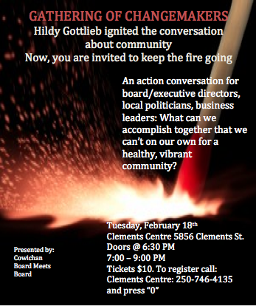

C:\Program Files (x86)\Microsoft Office\MEDIA\OFFICE12\Lines\BD14996_.gif

**FOR IMMEDIATE RELEASE** January 22, 2014

**VOLUNTEERS NEEDED FOR 6th ANNUAL WALK OF THE NATIONS**

For the sixth year in a row, Cowichan Valley community members will come together in May to celebrate the diversity of our community through the Walk of the Nations. Focused on sharing and celebrating culture and diversity, this event culminates with a symbolic walk of understanding, acceptance, respect and compassion through downtown Duncan.

More than 1000 people attended the Walk of the Nations in 2013 and volunteers are needed if this year’s Walk is to be successful. The Walk’s volunteer coordinator Emma Koch explains that having more people involved in the early planning stages will create a better event. Emma says, “We are always looking for fresh ideas and it is important to have different people from the community working on building this vision together. I know there are some great ideas out there that people may not have had the opportunity to share, so consider this an open invitation!”

The Walk of the Nations is hosted by Social Planning Cowichan in partnership with Cowichan Intercultural Society and Hiiye’yu Lelum (House of Friendship Society). This year’s Walk will take place Saturday May 31th, 2014. Although the Walk has taken different forms over the years but its essence remains true to its roots. Born out of the 2008 North American Indigenous Games, the Walk of the Nations is an opportunity for everyone to come together and celebrate the rich diversity of the Cowichan Region.

One of the best aspects of the Walk has been the ongoing and overwhelming support of the community. This year the Walk committee is reaching out to invite new people to participate in both the organizing of Walk events and in helping out during the event itself.

Committee member Amanda Marchand believes that to make this event successful 30 more volunteers are needed to come out and help on the day of the Walk. She goes on to encourage future Walk volunteers, “There are so many ways for volunteers to help. Volunteers are needed for the set-up team, the food and hospitality hosts, the cleanup crew, as stagehands and tear-down team.”

Volunteering is about more than hard work. Marchand explains, “This is such a great way to work together to celebrate the strength and diversity of our community and we encourage participation from every walk of life in the Valley, the more people come to support the day the stronger our community grows. Not to mention, it’s a lot of fun!”

Walk of the Nations is also looking for other contributions including food donations, sponsorships, tents, materials for kids stations and more.

To join this team of colorful community members, email Emma Koch at emma@cis-iwc.org or for other walk related information contact Social Planning Cowichan at michelle.spcowichan@gmail.com 2

Social Planning Cowichan researches, forms partnerships, creates strategies and informs the Cowichan public about social planning issues. Social Planning Cowichan is currently working on initiatives around affordable housing, cross-cultural relations, youth initiatives and coordinating with other partners on community issues. Our past successes include the 2010 Status of the Community report and the Affordable Housing Strategy. An update to the Status of the Community report is currently underway.

Social Planning Cowichan is always looking to involve the community in the work it does. Community members are encouraged to contact Social Planning Cowichan at (250) 746-1004 or www.socialplanningcowichan.org.

-30-

Media Contact:

Michelle Staples michelle.spcowichan@gmail.com or 250-709-7972.

Do you have a resource, event or information you would like to share?

Send it to [cindylisecchn@shaw.ca](mailto:cindylisecchn@shaw.ca) and it will be included in the weekly Health Matters Newsletter