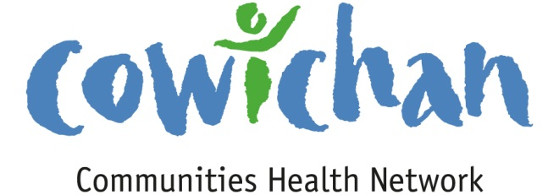

CHECK UP
January 25, 2013

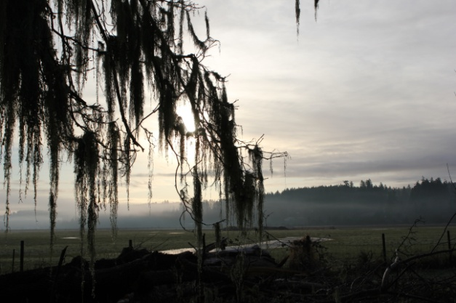
Hello Everyone,
On your way to get fresh bread from the bakery in Cowichan Bay... take a moment and stop at the park by the tennis courts.... the moss on the oaks at sunrise is spectacular. This is a great way to start a Saturday!
You can take an easy walk along the water and the dry dock trail.

Meetings
Budget Committee –January 25th -1:30 pm Meeting Room 1 CVRD- Gerry, Jennifer, Cindy, (Rob)
Communications Committee- February 5^{th-} 9:30 am Meeting Room 1 – CVRD, Cindy, Gerry, Rob, Anita, Amy
Asset Mapping and Research Committee- meeting plans still in progress-

Upcoming Events/ Workshops
- Don’t forget that the Ceevacs Running and Walking Clinic is Starting February 11 – April 29, 2013
Mondays at 6 pm at Duncan Christian School, 495 Beech Ave.
HOW MUCH DOES IT COST?
FitWalk, Learn to Run: Early bird fee – $100 Late entry after Feb 1 – $125
5k & 10K: Early bird fee – $100 Late entry after Feb 1 – $125
Half Marathon (16 wks): Early bird fee – $132 Late entry after Feb 1 – $145
DISCOUNT
Groups of 3 or more – $5 discount each *Drag out your Friends*
PROCEEDS
Proceeds from the 2013 Ceevacs Roadrunner Running and Walking Clinic are donated to the Cowichan Sportsplex.

It is official.......We have a New Mailing Address!
Cowichan Communities Health Network
PO Box 20106
Duncan BC,
V9L-5H1

Participate, Learn, Plan
“Citizen-Led Sustainable Change”: Innovations in North American Community Development,
To be held in Antigonish, Nova Scotia on June 23-25, 2013.
What are the most recent innovations in citizen-led community development across North America? How do citizens engage government and the private sector to support their initiatives? What types of partnerships and investments are most effective? These questions are critical as local communities re-examine their roles in creating and sustaining their assets and determining their own futures.
It’s time we talked. Development practitioners and researchers, as well as policymakers and funding agencies that support local initiatives, all have an interest – and a say – in the conversation about how citizens can best lead community development. We need to learn from one another’s experiences and build a collective platform to continue the conversation and increase its impact on the ground.
Towards these ends, St. Francis Xavier University is convening the forum

http://www.coady2.stfx.ca/coady/nacommdev/
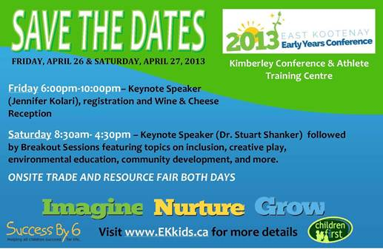

Bill C-233 Petition; An Act to Eliminate Poverty by Jean Crowder. The purpose of this bill is to impose an obligation on the federal government to eliminate poverty and promote social inclusion by establishing and implementing a strategy for poverty elimination in consultation with provincial, territorial, municipal and aboriginal governments and with civil society organizations. The purpose of this bill is for real nation-building where no one is left behind because it is an opportunity for us to collectively build healthy communities and strong economies. Please visit www.jeancrowder.ca to print off, sign and circulate the petition which asks the Government of Canada to take the elimination of poverty seriously!

Effective January 1, 2013: The City of Duncan will offer a full rebate on monthly transit passes
purchased by City of Duncan residents. The program will run until March 31, 2013 funds permitting. To Obtain a Rebate,City residents will purchase monthly transit passes at normal outlets,then apply for a refund. Residents will be asked to fill out a short application form, provide proof of residency, and submit a copy of the receipt from the purchase of their transit pass. The City will send a rebate cheque for qualifying purchases to the applicant. Application forms are available online at www.duncan.ca under City Hall - Forms & Applications, or in person at City Hall, the CVRD, and the Island Savings Centre. Mail or drop off your application to: City of Duncan - 200 Craig Street Duncan, B.C. V9L-1W3

The Hul'qumi'num' Health Hub is working in partnership with the Hul'qumi'num' nations and the Cowichan Division of Family practice to host a series of community engagement events entitled “Conversation on Health." These events are meant to provide an opportunity for First Nations community members to engage in dialogue with family doctors who work in the community.

The first event in this series was held in Stz'uminus and the second event is being held in Cowichan on Monday, January 28 at the Quw'utsun' Cultural Centre. Future sessions are being planned for the Penelakut, Malahat, Lyackson, Halalt and Lake Cowichan communities.

All Cowichan Tribes members are invited to participate in this event. Details are attached. Please feel free to share with Cowichan Tribes members.
Huy ch q'u,
Brennan
Brennan MacDonald
HUB Coordinator, Hul'qumi'num' Health
Tel: (250) 748-9760
Cell: (250) 732-0349 www.wearecoastsalish.com

