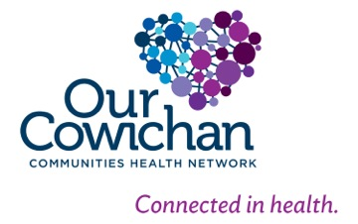

**Health Matters**

**February 21, 2014**

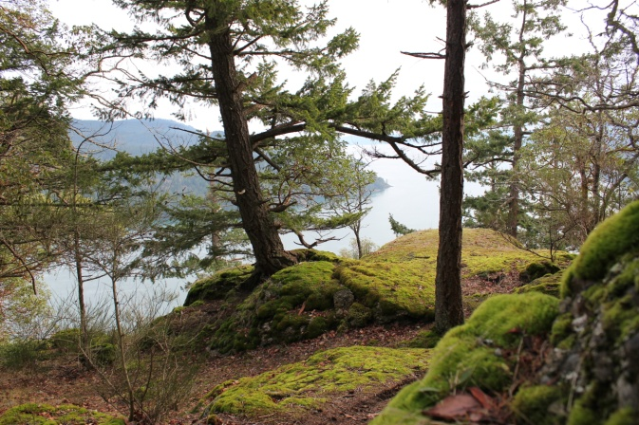Stoney Hill will be preserved as parkland! See the article below. The 12 key determinants of health include sustaining healthy natural ecosystems and this is a great example.

**Today’s Check up Includes:**

* Meeting Schedules
* Community meetings and Events
* Stoney Hill Parkland
* Workshop on Tenants Rights
* UBC Webinar on Family Violence

C:\Program Files (x86)\Microsoft Office\MEDIA\OFFICE12\Lines\BD14996_.gif

**CCHN Network Member Meetings-**

* **Asset Mapping and Research Committee meeting –** Monday February 24, 3:30 pm CVRD Room 213
* **Next Our Cowichan Network Meeting –**Thursday March 13, CVRD Board Room. Light dinner at 5:30 pm – Meeting starts at 6:00 pm

C:\Program Files (x86)\Microsoft Office\MEDIA\OFFICE12\Lines\BD14996_.gif

**Upcoming Events/ Workshops/ Community Meetings**

* **Cowichan Lake Health Fair-** Saturday March 1- 10 am to 3:00 pm – Centennial Hall- see ad below

C:\Program Files (x86)\Microsoft Office\MEDIA\OFFICE12\Lines\BD14996_.gif

**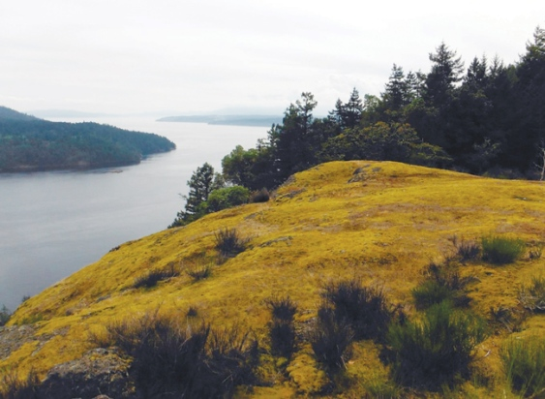Stoney Hill Parkland**

After 40 years of ownership, Paul Bourke and his family have opted to sell a plot of premier Maple Bay-area real estate to the Cowichan Valley Regional District for use as parkland."We used it for recreation - I never cut down a tree or branch of a tree," said Bourke, a 67-yearold Victoria resident. As such, the undisturbed 38.8-acre (15.7) hectare parcel overlooking Sansum Narrows will be a fine fit for inclusion into the relatively recently established Stoney Hill Regional Park. Created in 2011 through the CVRD's regional parkland acquisition fund, the 128-acre (51.6-hectare) park borders Bourke's former land, making for an impressive 165-acre (66 hectare) space atop Sansum Point. Besides the Narrows, views of Saltspring Island and the Saanich Inlet are also unfettered from the property's position 220 metres above sea level. The land - an investment and retirement project for Bourke -cost the regional district $925,000. He said he was willing to sell simply because it was time to let go."You got to downsize," he said. "Everything's got to go sooner or later. It will be in good hands."Board chair Rob Hutchins said the CVRD is grateful for Bourke's willingness to sell. "This land acquisition provides a key extension to the protection of the bluffs above Sansum Narrows, preserving dramatic viewscapes and a place of special significance to many within the Cowichan Valley," he said. Still only really accessible from the water, there is no road access to the park from Genoa Bay Road just yet but residents of the nearly-off-the-grid neighbourhood have been working with the Municipality of North Cowichan for more than a year to change that. In the meantime, the CVRD has requested curious outdoors people respect the private property of neighbours and not to trespass. With files from the Times Colonist © Cowichan Valley Citizen - See more at: http://www.cowichanvalleycitizen.com/news/cvrd-buys-stoney-hill-parkland-1.853685#sthash.AaYLJ3As.dpuf

C:\Program Files (x86)\Microsoft Office\MEDIA\OFFICE12\Lines\BD14996_.gif

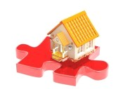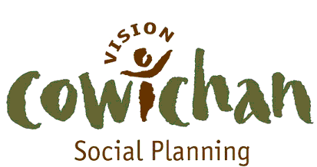

**The Regional Affordable Housing Directorate**

Invites you to a informative workshop on Tenants Rights

**Focus:** ***Residential Tenancy Law***

**Presenter:** **Russ Godfrey**

Tenant’s Resource & Advisory Centre

This session is geared for Service Providers who are working with tenants who have concerns about their housing rights and situation.

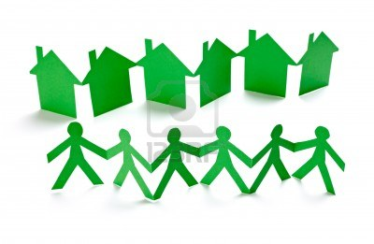Thursday, February 27, 2014

Duncan United Church, Ingram St., Heritage Room

1:30 to 3:00

To register in advance contact Joy at [joyspcowichan@gmail.com](mailto:joyspcowichan@gmail.com)

C:\Program Files (x86)\Microsoft Office\MEDIA\OFFICE12\Lines\BD14996_.gif

**UBC Learning Circle- WEBINAR**

**Special Edition on Family Violence**  
Albert Pooley: Addressing Family Violence  
  
The UBC Learning Circle has partnered with the National Collaborating Centre for Aboriginal Health to present Mr. Albert M. Pooley, MSW, MPA, President & Founder of the Native American Fatherhood & Families Association in a special live webinar on addressing family violence.

Family is at the heart of Native American cultures.  There is no other work more important than fatherhood and motherhood.  Fathers must take primary responsibility in bringing happiness and safety to his family, and as First Nations people, we must take the lead in keeping our families together.  To do this, we must recognize the urgent need to address family violence. This workshop will provide information on how NAFFA is committed to addressing family violence through responsible fatherhood and motherhood.  Participants will learn why fatherhood and motherhood are sacred, why freedom of choice is important, and how the importance of personal choice is linked to family violence.

**Date:** Tuesday, February 18, 2014

**Time**: 2:00 to 4:00 p.m. PST

**Location**: Participate by computer webinar

**Free Registration**

Registration: Click [**here**](http://ubc.us6.list-manage.com/track/click?u=8f90692f19eaeaf98686d5357&id=ee115b487e&e=0bb40c9340)to register  
  
  
\*Pre-registration is required attend\*

C:\Program Files (x86)\Microsoft Office\MEDIA\OFFICE12\Lines\BD14996_.gif

[If all the Friends of Choose Cowichan Lake could share this photo, that would be awesome !!!
See You There - you will leave Healthier than when you came !!!](https://www.facebook.com/photo.php?fbid=377999075648637&set=a.292323300882882.1073741828.289579617823917&type=1)

Do you have a resource, event or information you would like to share?

Send it to [cindylisecchn@shaw.ca](mailto:cindylisecchn@shaw.ca) and it will be included in the weekly Health Matters Newsletter