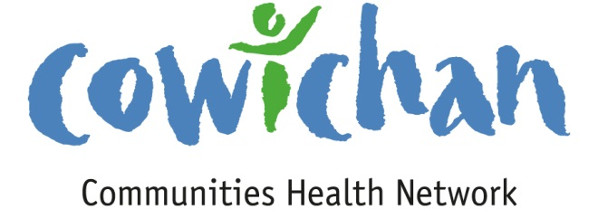

**CHECK UP**

February 15, 2013

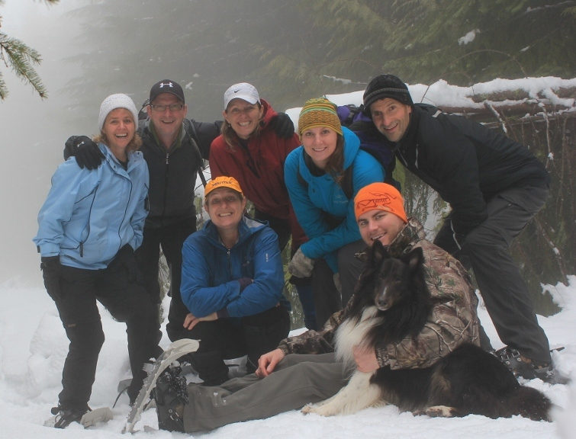

Hello Everyone,

Every person should experience a new adventure when they can. This week mine was snowshoeing on Mount Brenton. I would love to share the wonderful scenery but unfortunately we were fogged in for the day, but, what I can tell you is that we had a ton of fun! You will need a vehicle that can take you to the base of the mountain via the rough Chemainus Logging Road. The hike is strenuous but we happily did 5.5 kms straight up before turning around. (This hike is not for the ill prepared in winter conditions and the gate closes at 4:30 so you will need to be diligent with time).

C:\Program Files (x86)\Microsoft Office\MEDIA\OFFICE12\Lines\BD14996_.gif

**Meetings**

**Admin Committee** February 20, 5:30 pm Committee Room 2

C:\Program Files (x86)\Microsoft Office\MEDIA\OFFICE12\Lines\BD14996_.gif

**Upcoming Events/ Workshops/ Community Meetings**

* **Board Meets Board**

March 12, 2013 @ 5:30 pm New Life Baptist Church

1839 Tzouhalem Road Duncan BC

**Social Innovation: Building Upon Ideas**

Colleen McCormick Director of Innovative Partnerships, Ministry of Social

Development.

* We will focus on possibilities for connection and cooperation amongst community based social services, businesses, and local government in addressing key challenges facing our community and in building upon what is already working

***Cost: $15 per person To register:***

Must be paid in advance United Way Cowichan 1 Kenneth Place

Deadline for registration: In person: cheque or debit

March 7, 2013 By phone: 250-748-1312

Master Card, Visa, American Express

* **Blood Donor Clinic in Duncan DONORS NEEDED**

|  |  |
| --- | --- |
|  | **February 26 2013, February 27 2013, February 28 2013** |
|  |  |
|  | 1:00 pm |
|  |  |
|  | Island Saving Centre Duncan |
|  |  |

Canadian Blood services are holding a blood donor clinics Tuesday (1:15pm – 7:15pm), Wednesday (1:15pm – 7:15pm) and Thursday (12- 6pm) in the Island Saving Centre Duncan

Canadian Blood Services is in need of more blood donors, Please consider donating an hour of your time to save three lives.

To book an appointment to donate blood call 1-888-2-DONATE or go online [www.bloodservices.ca](http://www.bloodservices.ca)

C:\Program Files (x86)\Microsoft Office\MEDIA\OFFICE12\Lines\BD14996_.gif



**Fall/Winter Institute**

**Belonging and Influence in Community Organizations**

**You are invited to lunch . . . and learn**

**Tuesday February 26: 12 noon ‘til 3 p.m.**

**We will explore and reflect on:**

* what we know about the role of diversity and meaningful participation in creating more effective decision-making processes and structures in our groups and organizations
* the current state of our organizations’ policies and practices that encourage diversity and equal participation
* the results of a recent Community Survey of Leadership Diversity

**We will learn from one another:**

* about the challenges and joys of creating groups and organizations that are diverse and representative
* what tools and resources are available to us and what may be helpful

**To RSVP please call:** 250-748-2133 **or email:** info@preparethepath.ca

**Duncan United Church - 246 Ingram Street**

**Scent free please**

Sponsored by Volunteer Cowichan with financial assistance from Status of Women Canada

Volunteers Grow Communities

Volunteer Cowichan

C:\Program Files (x86)\Microsoft Office\MEDIA\OFFICE12\Lines\BD14996_.gif



Joanne Schroeder

Acting Deputy Director

440–2206 East Mall Vancouver

BC Canada V6T 1Z3

Phone 604 827 5396 Fax 604 822 0640

joanne.schroeder@ubc.ca

www.earlylearning.ubc.ca

Hello all,

It is with the deepest sorrow that we announce the sudden passing of Dr. Clyde Hertzman. Clyde’s influence in the fields of early child development, population health and epidemiology has been significant within B.C., nationally and internationally.

Thank you all for your support and work with us through this difficult time. Although it is difficult for us to fathom, we are carrying on with the work of HELP and will soon have an interim Director in place. We feel empowered to continue the vision and the work that Clyde began here at HELP. We are assisting his family in planning a celebration of Clyde’s life within a few weeks, and will share the details once they are finalized. We have been very grateful for your messages about Clyde and your thoughts of us at HELP. We are gathering tributes to create a collection of remembrances honouring Dr. Hertzman's life and work, and welcome your thoughts here:

http://earlylearning.ubc.ca/remembering-clyde-hertzman/

The rich research legacy Clyde left us can be found on the Human Early Learning Partnership (HELP) website: [http://earlylearning.ubc.ca/blog/2013/feb/08/dr-clyde-hertzman/](http://cts.vresp.com/c/?FirstCallBCChildandY/dd7ef615e8/0e61ad4606/e404b2b10e) and embedded in bibliographies and innumerable other sites and publications that form the foundation of research into the early years and the social determinants of health.

Thank you for your support,

Joanne Schroeder

Deputy Director

Human Early Learning Partnership

C:\Program Files (x86)\Microsoft Office\MEDIA\OFFICE12\Lines\BD14996_.gif

**Bill C-233 Petition; An Act to Eliminate Poverty by Jean Crowder.**

The purpose of this bill is to impose an obligation on the federal government to eliminate poverty and promote social inclusion by establishing and implementing a strategy for poverty elimination in consultation with provincial, territorial, municipal and aboriginal governments and with civil society organizations. The purpose of this bill is for real nation-building where no one is left behind because it is an opportunity for us to collectively build healthy communities and strong economies. Please visit www.jeancrowder.ca to print off, sign and circulate the petition which asks the Government of Canada to take the elimination of poverty seriously!

**C:\Program Files (x86)\Microsoft Office\MEDIA\OFFICE12\Lines\BD14996_.gif**

**BC Association of Family Resource Programs**

This newsletter is always loaded with great information on the determinants of health

<<http://us5.campaign-archive1.com/?u=d45c4ce08c0e1d6d05efb689b&id=ac615d4ae4&e=a4b354228b>>.

C:\Program Files (x86)\Microsoft Office\MEDIA\OFFICE12\Lines\BD14996_.gif

# Giving children a chance

Original Text

[The Lancet](http://www.thelancet.com/search/results?fieldName=Authors&searchTerm=%20The%20Lancet)

Last week, the World Policy Analysis Centre released a new report, which for the first time systematically presented comparative data on laws and public policies in 191 countries covering areas essential to children's healthy development. [*Changing Children's Chances*](http://childrenschances.org/) examines policy data and their impact in the areas of poverty, discrimination, education, health, child labour, child marriage, and parental care. The report provides a global picture of the policy tools governments can use to make a difference to children's opportunities in life.

Overall, the report shows that governments have largely failed to keep their commitments to international agreements, and are not providing enabling environments for children to fulfil their potential. Whether it is poverty reduction, provision of child-friendly working policies, or freedom from discrimination, it is evident that the bar has not been set high enough for what is necessary, either for children to thrive or for them to achieve adequate health. However, across regions there are variations in the areas examined, and a few countries, unexpectedly, are ahead of the curve. For example, good progress has been made on universal primary education. 166 countries have free primary schools. But progress in [secondary education](http://childrenschances.org/global-maps/beyond-basic-education/is-completing-secondary-education-tuition-free-and-compulsory/) has lagged behind. Whereas Latin America and large parts of Asia and the Pacific provide free secondary education, opportunities in sub-Saharan Africa without tuition fees are limited, and as a result exclude the poor. Given the transformative role that secondary education plays in health and development—as shown, for example, by the positive correlation between maternal education and reduced child mortality—more needs to be done to remove this financial barrier.

Similarly, for health, the report notes that poor availability and delivery of health care characterise countries where government investment in health is low. These countries could be doing much more to make services available to their populations. The report also reveals which policies can make a difference. For example, the impact of maternity leave on breastfeeding. The best available data show that an extra 10 weeks of [paid maternity leave](http://childrenschances.org/global-maps/parents-and-children/is-paid-leave-available-for-mothers-of-infants/) is associated with 10% lower infant mortality and 9% lower mortality in children younger than 5 years. Furthermore, 136 countries guarantee supportive labour policies that allow [breastfeeding breaks at work](http://childrenschances.org/global-maps/parents-and-children/are-mothers-of-infants-guaranteed-breastfeeding-breaks-at-work/).

According to the report, many governments fail girls, notably in protecting them from child marriage, a practice that is inextricably linked to gender inequity. As well as dropping out of school, early marriage results in early childbirth, which can have serious effects on mothers and children. Additionally, girls in these marriages are at increased risk of gender-based violence. Early marriage is sometimes thought to be a purely cultural or family decision, but the report shows that governments are also culpable. In several countries there is [no minimum legal age of marriage](http://childrenschances.org/global-maps/a-chance-at-childhood/how-long-are-girls-protected-from-marriage-compared-to-boys/), and in 54 countries girls are legally permitted to marry between 1 year and 3 years younger than boys. Similarly, the report shows that many countries do not have national laws and policies that comply with international agreements to [protect children from labour](http://childrenschances.org/global-maps/a-chance-at-childhood/how-long-are-children-protected-from-full-time-work/). These children are more likely to be injured, tend to have poorer health outcomes, and are not in education. Yet, in several countries children may work full-time as young as 12—13 years of age.

The report represents an impressive body of work that has taken a decade to complete and begins to quantify what countries are actually doing to make a difference to children's lives. It suggests that many inadequacies in national policies and laws are due to lack of political will, even though several policies are readily affordable, such as breastfeeding breaks in the workplace, making it illegal for children to do hazardous work, and enacting non-discrimination laws. Given that these data will be made publicly available, they should allow civil society to put pressure on countries and hold national policy makers to account, especially those governments lagging behind.

As discussions on the post-2015 development goals continue, the global community should use these findings to address gaps not only within the health sector, but also between sectors that crucially influence health and conditions for health. Commenting on the report, Michael Marmot, Director of University College London's Institute of Health Equity, says: “What happens in a child's early life—regardless of where they are in the world—very much determines their chances to lead healthy and productive lives in their adulthood.” Governments owe it to children—and to the sustainability of their national interests—to provide their youngest citizens with the best possible opportunity to ensure these chances are not missed.