****

**Health Matters**

**April 4, 2014**

**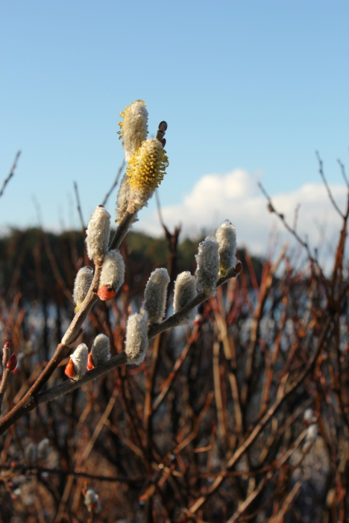Today’s Check up Includes:**

* Meeting Schedules
* Community meetings and Events
* Health Survey- Link for sharing broadly
* Link to Report on Social Progress
* Ready Set Learn Events
* Invitation for Community Meeting re: RFP for Early Years Centre
* World Health Events ( Attached Documents)

C:\Program Files (x86)\Microsoft Office\MEDIA\OFFICE12\Lines\BD14996_.gif

**Our Cowichan- Network Member Meetings-**

* **Next Our Cowichan Network Meeting –**Thursday April10, CVRD Board Room. Light dinner at 5:30 pm – Meeting starts at 6:00 pm
* **Next Admin Committee Meeting-** Wednesday April 17, 5:30 pm CVRD committee room 2

C:\Program Files (x86)\Microsoft Office\MEDIA\OFFICE12\Lines\BD14996_.gif

**Upcoming Events/ Workshops/ Community Meetings**

* **Cowichan Aboriginal Festival of Film and Art-** April 23-26 at the Cowichan Theatre. Tickets at Cowichan Ticket Centre- Films- Workshops- Art- Performance- Focus Groups- Youth Awards Night- for more info go to [www.aff.cowichan.net](http://www.aff.cowichan.net)

C:\Program Files (x86)\Microsoft Office\MEDIA\OFFICE12\Lines\BD14996_.gif

**Cowichan Health Survey**

**WE WANT TO HEARFROM YOU!**

The purpose of this survey is to collect information from the communities served by ***Our Cowichan Communities Health Network*** to gain a better understanding of the current health and wellness of our residents. The information collected will be used to develop a Community Health Profile for the Cowichan region. This profile will ultimately be used to identify where we are doing well as well as gaps or barriers that impact health.  We will learn from this information and will work together to find community based solutions to improve the health of our communities and residents.

***We kindly ask that you complete the survey and that you share this link far and wide across the Cowichan Region.*** *( A pdf version has also been attached for you to print )*

**YOUR SURVEY RESPONSE WILL BE ANONYMOUS**

<http://fluidsurveys.com/s/CowichanCommunityHealthSurvey/>

C:\Program Files (x86)\Microsoft Office\MEDIA\OFFICE12\Lines\BD14996_.gif

**Link to Report on Social Progress**

Here is a link to a very interesting report, <http://www.socialprogressimperative.org/>.

Social Progress Imperative released their Social Progress Index 2014. The organization is making the argument that an economic perspective to measure performance of a nation, just considering growth of the GDP is very limited and doesn’t provide a full picture for citizens and decision makers.

C:\Program Files (x86)\Microsoft Office\MEDIA\OFFICE12\Lines\BD14996_.gif

**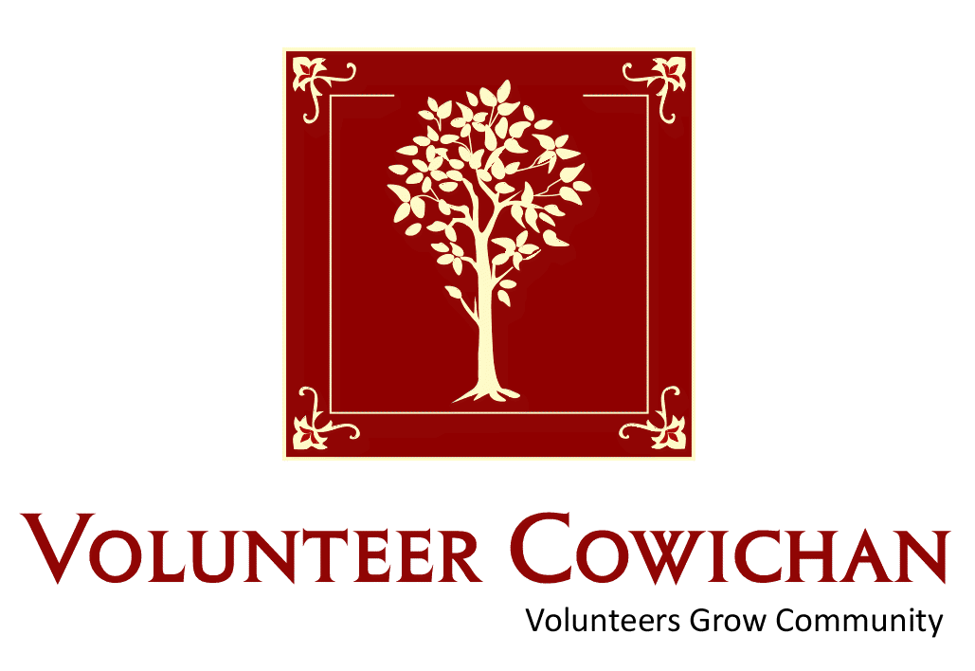**

Cowichan Volunteer &

Community Resources Fair

Find a Volunteer Opportunity &

Community Resource that’s right for you!

Duncan Mall

Saturday, April 5, 2014

10:00 am – 2:00 pm

Display booths, Connect with Valley Non Profits & Volunteer supported Organizations, Find out about Community Resources

available for Youth, Families & Seniors.

Cake, Door Prizes, & Helping Hands Volunteer Recognition @ 1pm

FOR MORE INFORMATION

PHONE: 250-748-2133 EMAIL: vc@volunteercowichan.bc.ca

[www.volunteercowichan.bc.ca](http://www.volunteercowichan.bc.ca)

**

Many thanks to all of our valued sponsors and supporters during

National Volunteer Week April 6-12, 2014

****

**Ready, Set, Learn** -Ready, Set, Learn is a ‘Drop-in’ Educational and Health Fair helping your preschooler get ready for school. For Families and Children Ages 3-5 years.

**Friday April 4th at Chemainus Community School,**

**Thursday, April 10th at Shawnigan Lake Community Centre,**

**Thursday, April 17th at Duncan Mall,**

**Thursday April 24th at Palsson Elementary School.**

**Receive information on:** **Participate With Your Child In:**

Health & Nutrition Language Centres

Dental Play Centres

Vision Math Centres

Child Development Reading Centres

Language Development Story Times

Social & Emotional Development Music Times

Childcare & Pre School Programs

Success By 6

C:\Program Files (x86)\Microsoft Office\MEDIA\OFFICE12\Lines\BD14996_.gif

**Invitation to Community Meeting Re: RFP for Early Years Centre**

The MCFD has announced a request for proposals (RFP) from communities for the creation of Early Years Centre Test Sites in up to 10 communities.  The Province has clearly identified the Success by 6 Council of Partners and the Aboriginal Success by 6, Ya Ya Tal as our community tables that are required to endorse any RFP application that is to be forwarded to the province and the government is asking communities to work together to submit only one application.

For our community to submit a proposal, our goal is to facilitate a conversation that has community representation from all areas.  We need to show the government that we are coming from a place of community consensus and that all parties have a significant investment.

You are invited to join us in a discussion of the needs are of Children and Families 0-6 in the Cowichan Valley that could be supported by an Early Years Centre.  We are looking at community input to help build a strong RFP that is reflective of community, and we hope that through this process we can identify a lead agency to lead in this work.

Due to the ***very tight timeline*** with a deadline from the Province of Friday, April 25th at 2:00 pm, this community meeting will be held on:

**Monday, April 7th at 1:30 PM**

**Location:  Annex Building at the School Board Office**

We hope to see you there,

Thank you,

Laura

Laura Court,

Cowichan Success By 6 Coordinator

Telephone:  250-701-3647

Email:  [cowichansuccessby6@shaw.ca](mailto:cowichansuccessby6@shaw.ca)

Do you have a resource, event or information you would like to share?

Send it to [cindylisecchn@shaw.ca](mailto:cindylisecchn@shaw.ca) and it will be included in the weekly Health Matters Newsletter