





**Health Matters Newsletter**

**April 25, 2014**

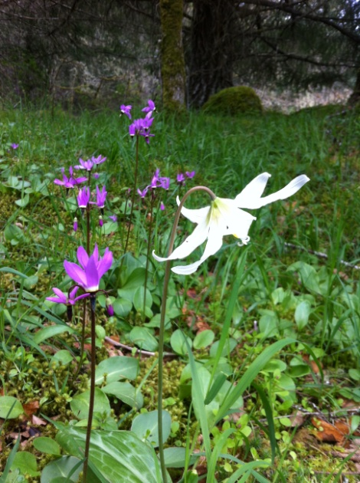The Cowichan Valley Trails are filled with spectacular wild flowers at this time of year. Be sure to check out the Tzouhalem Wild Flower Reserve, Stoney Hill Trail on Genoa Bay Road and the Gary Oak Reserve via Trillium Terrace and York Road.

**Today’s Health Matters Includes:**

* Meeting Schedules
* Community meetings and Events
* Reminder of the Our Health System On Line Resource
* BC Communities Health Atlas- on line maps
* NEW! Healthy Built Environment Linkages Toolkit
* Healthy Communities News Letter link
* Volunteer Job Posting
* Elder Abuse and Neglect Workshop

C:\Program Files (x86)\Microsoft Office\MEDIA\OFFICE12\Lines\BD14996_.gif

**Our Cowichan- Network Member Meetings-**

* **Next Asset Mapping and Research Committee meeting-** Monday April 28, 12 noon CVRD Committee Room 1
* **Next Our Cowichan Network Meeting –**Thursday May 8, CVRD Board Room. Light dinner at 5:30 pm – Meeting starts at 6:00 pm
* **Next Admin Committee Meeting-** Wednesday May14 , 5:30 pm CVRD committee room 2

C:\Program Files (x86)\Microsoft Office\MEDIA\OFFICE12\Lines\BD14996_.gif

**Upcoming Events/ Workshops/ Community Meetings**

* Gathering Change Makers with Dr Paul Hasselback – May 13 New Life Baptist Church- see advertisement below.
* Elder Abuse/ Neglect workshop- see advertisement below

C:\Program Files (x86)\Microsoft Office\MEDIA\OFFICE12\Lines\BD14996_.gif

**A reminder of a good resource** [CIHI releases OurHealthSystem.ca](http://u.info-hcc-ccs.ca/t/1_1jhmxf7v4j9/ourhealthsystem.ca/) –

In November 2013, the Canadian Institute for Health Information (CIHI) released a new interactive website, [**OurHealthSystem.ca**](http://u.info-hcc-ccs.ca/t/1_1jhmxf8v4j9/ourhealthsystem.ca/), as part of a three-year plan to enhance its work on pan-Canadian health system performance reporting and to improve support for jurisdictional efforts to improve care and the health of Canadians.  
  
The website provides comparable information on broad health system performance that can be viewed at the national and provincial/territorial levels, and in some instances, at the health region and facility levels. Information is available on five areas of performance measurement that Canadians identified as being important to them: access to care, quality of care, health spending, health promotion and disease prevention, and health outcomes. The website currently displays results on a total of 15 performance indicators; viewers are able to see how provinces and territories compare with the national average and how performance has changed over time. In some cases, data are available on health region or hospital-level results. Health regions and hospitals that are considered top performers (have been in the top 10% for the last three years) are highlighted.

C:\Program Files (x86)\Microsoft Office\MEDIA\OFFICE12\Lines\BD14996_.gif

**BC Communities Health Atlas-**

<http://maps.gov.bc.ca/ess/sv/cha/>

C:\Program Files (x86)\Microsoft Office\MEDIA\OFFICE12\Lines\BD14996_.gif

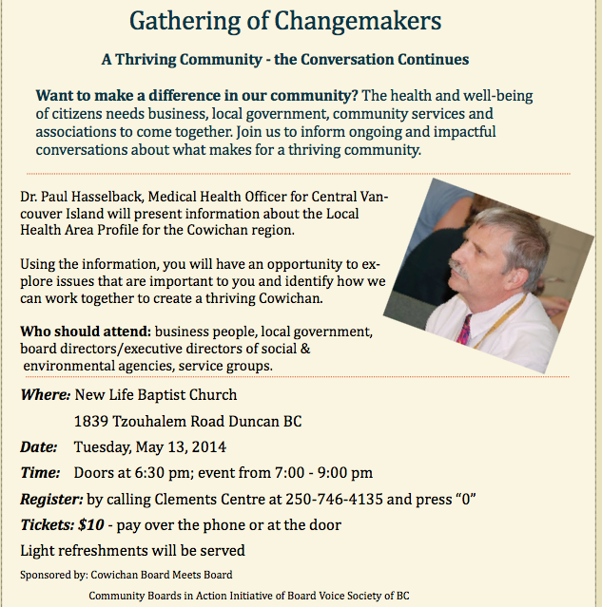

C:\Program Files (x86)\Microsoft Office\MEDIA\OFFICE12\Lines\BD14996_.gif

**NEW! Healthy Built Environment Linkages Toolkit**

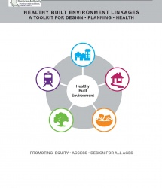

How can local governments link planning principles to health outcomes?

[Download (PDF)](http://planh.ca/sites/default/files/linkages_toolkit_final_april_8_2014_full.pdf)

The *Healthy Built Environment (HBE) Linkages Toolkit,* developed by the [PHSA Population and Public Health team in partnership with the Healthy Built Environment (HBE) Alliance](http://www.phsa.ca/HealthProfessionals/Population-Public-Health/Healthy-Built-Environment/default.htm),  is the first evidence-based and expert-informed resource that links planning principles to health outcomes.

Intended to inform built environment design and decision-making, the Toolkit summarizes health evidence related to the five physical features of the built environment (neighbourhood design, transportation networks, natural environments, food systems, and housing).

By referring to the *HBE Linkages Toolkit*, local governments can **quickly understand key factors related to the built environment that influence health in their community**, and planners can **access a reliable summary of the health evidence that will support their daily work.**

The *HBE Linkages Toolkit* is different from other toolkits because it provides a framework for thinking and talking about health and the built environment without prescribing which actions to take. The Toolkit is intended to be a conversation starter between planners, public health professionals, and local governments regarding “what” to do.  Other resources such as PlanH complement the *HBE Linkages Toolkit* by offering solutions about “how” to plan and design healthy built environments.

* [Download the HBE Linkages Toolkit (PDF)](http://planh.ca/sites/default/files/linkages_toolkit_final_april_8_2014_full.pdf)
* [Download the HBE Linkages Toolkit 2-Pager (PDF)](http://planh.ca/sites/default/files/linkages_toolkit_2-pager_final_april_8_2014.pdf)

**RELATED EVENTS**

* **POSTPONED!** [**Healthy People Healthy Places: Exploring healthy built environments ~ April 25, 2014**](https://www.eventbrite.ca/e/healthy-people-healthy-places-exploring-healthy-built-environments-tickets-10994878979) **POSTPONED!**  
  Join this inspirational morning of knowledge sharing and dialogue on planning and designing our communities for greater health and well-being.   
  The BC Ministry of Health will be unveiling The Healthy Built Environment Linkages Toolkit. This is your chance to hear about this great resource from Matt Herman, Executive Director of the Healthy Living Branch.  
  [Download poster (PDF)](http://planh.ca/sites/default/files/healthy_people_healthy_places.jpg) or to register [click here](https://www.eventbrite.ca/e/healthy-people-healthy-places-exploring-healthy-built-environments-tickets-10994878979)
* [**Linkages Toolkit Webinar ~ April 30, 2014**](http://www.chnet-works.ca/)  
  Attend this special CHNET webinar to learn how the *HBE Linkages Toolkit* can improve the health of the built environment in your community.   
  [Download poster (PDF)](http://planh.ca/sites/default/files/chnet_poster_final.pdf) or to register [click here](http://www.chnet-works.ca/index.php?option=com_rsevents&view=events&layout=show&cid=293%3Ahealthy-built-environment-linkages-a-toolkit-for-design-planning-health&Itemid=94&lang=en)

**REQUEST FOR FEEDBACK**

Please help us gather information about whether and how people might use the toolkit by filling out this [short survey](http://fluidsurveys.com/surveys/pphphsa/healthy-built-environment-linkages-toolkit/).

We would greatly appreciate it if you could please take the time to complete the survey, forward the [survey link](http://fluidsurveys.com/surveys/pphphsa/healthy-built-environment-linkages-toolkit/) when you distribute the toolkit, and also consider adding similar questions to the evaluation forms for any event where the toolkit is being used or presented.

For any additional questions, comments or feedback please contact [pph@phsa.ca](mailto:pph@phsa.ca)

[http://planh.ca/sites/default/files/pictures/logos/bchc-logo.jpg](http://bchealthycommunities.ca/)  [http://planh.ca/sites/default/files/pictures/logos/hfbc-logo.jpg](http://www.healthyfamiliesbc.ca/)

C:\Program Files (x86)\Microsoft Office\MEDIA\OFFICE12\Lines\BD14996_.gif

|  |  |  |
| --- | --- | --- |
| |  | | --- | | **http://staticapp.icpsc.com/icp/loadimage.php/mogile/804138/b42bc20d794eadc0a80ead62dc2867bd/image/jpeg** | | Yours to behold: BC Healthy Communities Society  April Newsletter  [Get the news!](http://click.icptrack.com/icp/relay.php?r=12391125&msgid=264533&act=AZCF&c=804138&destination=http%3A%2F%2Fbchealthycommunitiesca.blogspot.com%2F) | |

C:\Program Files (x86)\Microsoft Office\MEDIA\OFFICE12\Lines\BD14996_.gif



ASBClogo_k

JOB DESCRIPTION

**Job title:** **Volunteer Walk Committee Chair**

**Reports to:** **Special Events Officer**

The ***Investors Group Walk for Memories*** is an annual fundraising event that raises funds and awareness about Alzheimer's disease and other dementias in B.C. communities. Next year's event will take place in communities across B.C. on **January 25, 2015**, as part of *National Alzheimer**Groups Walk* and it will ensure that Alzheimer Society of B.C. programs and services are available for more than 70,000 people in British Columbia who are living with Alzheimer's disease or other dementias.

**Job Summary:**

Responsible for leading and motivating a volunteer committee which in turn, is responsible for the successful staging of the ***Investors Group Walk for Memories*** fundraising event on January 25, 2015 in your community.

**Key Responsibilities:**

* Maintaining regular contact with the Special Events Officer for feedback, instruction and support
* Reviewing and becoming familiar with guidelines as set out by the Society and as communicated by the Special Events Officer
* Attending annual training workshops for Walk Chairs
* Recruit a team of volunteers to form the *Investors Groups Walk for Memories* Volunteer planning committee
* Acting as liaison between the Special Events Officer and the volunteer committee
* Ensuring committee members are familiar with guidelines
* Motivating, supporting and assisting volunteer planning committee members with their roles
* With the committee, establishing a fundraising goal for the event
* Participating in regular conference calls with Volunteer Walk Chairs and the Special Events Officer
* Overseeing the *Investors Group Walk* for Memories event timeline
* Ensuring all funds/ materials/ reports are submitted appropriately
* Gather volunteer time-tracking forms from committee
* Submitting all deposit and pledge forms and financial reports to Alzheimer Society of B.C.
* Ensuring volunteers and sponsors are thanked.

NOTE: Occasional overtime (evenings and weekends) may be required.

## **Qualification and Skills:**

* Three to five years of successful related fundraising experience with demonstrated knowledge and expertise in relationshipbuilding (corporate and marketing experience an asset)
* Ability to work effectively with senior volunteers and experience working with volunteer committees
* Superior customer service skills
* Initiative, problem solving skills
* Strong organizational skills
* Strong communication skills
* Flexibility and ability to work under pressure to meet deadlines

**Position Type:**

* Volunteer, Part-time

**Location:**

* Cowichan Valley

Please submit your application including your resume by email to **Daphne Tsai, dtsai@alzheimerbc.org**

**Website**: <https://walkformemories.com>

**C:\Program Files (x86)\Microsoft Office\MEDIA\OFFICE12\Lines\BD14996_.gif**

**Strategies for inter-professional health care providers to address elder abuse/ mistreatment**

Hello members of the Cowichan Seniors Network (CSN) and Cowichan Community Response Network (CCRN),

*At the last meeting of the Cowichan Seniors Network on March 24th, one of our members, Karen Davies, offered to facilitate a workshop on Elder Abuse.  The invitation is extended to other service providers and our appreciation goes to Karen for doing this!*

The Cowichan Seniors Response Network (CSN) ispleased to be hosting a professional development workshop as part of a collaborative effort to raise awareness of abuse and neglect of older people.  This workshop is designed for service providers and will be one in a series of events in preparation for World Elder Abuse Awareness Day (WEAAD):  June 15th.   We are planning other learning events designed for family, friends and neighbours and we will send you those notices as well.

Please note that we ask you to pre-register because we have space for up to 30 people.  If there is interest from many more people, we will hold a second workshop.

**Workshop Title:**

**Strategies for inter-professional health care providers to address elder abuse/ mistreatment**

**Sponsor:** Canadian Association of Occupational Therapists

**Trainer:** Karen Davies, Occupational Therapist

**When:** April 29 1:00 pm to 3:00 pm

**Location:** Cowichan Regional Library “The Gathering Place” at the back of the library in Duncan

**To Register Contact:** [wc@volunteercowichan.ca](mailto:wc@volunteercowichan.ca) or call 250-748-2133

C:\Program Files (x86)\Microsoft Office\MEDIA\OFFICE12\Lines\BD14996_.gif

Do you have a resource, event or information you would like to share?

Send it to [cindylisecchn@shaw.ca](mailto:cindylisecchn@shaw.ca) and it will be included in the weekly Health Matters Newsletter