****

**Health Matters Newsletter**

**November 3, 2017**

**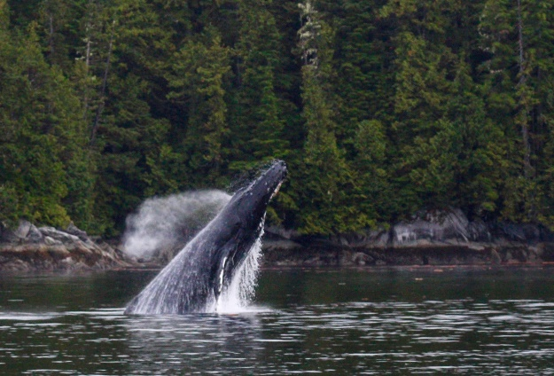Today’s Health Matters Includes:**

* Meeting Schedule
* Community Meetings and Events
* Data/ Research Cost of Homelessness
* Active 4 Life Summit
* Homelessness from an Aboriginal Perspective
* Christmas Chaos Invitation to Community Partners
* Run for the Claus
* Literacy and the Outdoor Classroom Webinar

C:\Program Files (x86)\Microsoft Office\MEDIA\OFFICE12\Lines\BD10358_.gif

**Our Cowichan- Network Member Meetings-**

* **Next Admin Committee Meeting- December 7, 4:30-6:30** CVRD Committee Room 2
* **Next Our Cowichan Network Meeting** at **November 9 Ramada Silver Bridge**. Light dinner at 5:15 pm Meeting starts at 5:45 pm.

C:\Program Files (x86)\Microsoft Office\MEDIA\OFFICE12\Lines\BD10358_.gif

**Community Events- Meetings**

* **Community Response Team Meeting** November 16, 9 am-11amMeeting Room 213 at the CVRD
* **EPIC-Community Steering Committee** November 16, 1:30 -3:30 pm Ts’i’ts’uwatul’ Lelum

C:\Program Files (x86)\Microsoft Office\MEDIA\OFFICE12\Lines\BD10358_.gif

**Local Data and or Research-**Cost of Homelessness -Cowichan Housing Association

<http://www.cowichanhousing.com/uploads/4/9/6/0/49605357/cost_of_homelessness_snapshot_april_2017.pdf>

C:\Program Files (x86)\Microsoft Office\MEDIA\OFFICE12\Lines\BD10358_.gif

**Active 4 Life · A Physical Literacy Summit You won’t want to miss this!**

**November 24 | 6:30 pm - 9:15 pm and** **November 25 | 8:00 am - 2:00 pm**

**Island Savings Centre**

**Registration fee $25**

**Includes lunch on Saturday**

**What is Physical Literacy?**

The motivation, confidence, physical competence, knowledge and understanding to value and take responsibility for engagement in physical activities for life.

**Who is it for?**

These fun presentations are geared for parents, coaches, youth leaders, educators, health practitioners and recreation instructors working with children and youth.

**Why You’ll Want to Attend**

**·** Learn practical activities you can use in your programs and lessons

**·** Includes tips and tricks for enriching your physical and health services

**·** Gain strategies to reverse the trends around inactivity in our community

For Session Information, visit **www.cvrd.bc.ca**

To register, call or visit:

**Cowichan Lake Recreation** at **250.749.6742 - Island Savings Centre** at **250.748.7529**

**Kerry Park Recreation Centre** at **250.743.5922**

**C:\Program Files (x86)\Microsoft Office\MEDIA\OFFICE12\Lines\BD10358_.gif**

**Homelessness from and Aboriginal Perspective**

link to an article about an Aboriginal man who is redefining homelessness from an Aboriginal perspective.  His name is Jesse Thistle.  I understand he was a keynote speaker at the recent national conference on homelessness that took place last week. He also has a profile on the Homeless Hub site. Formerly homeless himself, Mr Thistle frames homelessness from an Aboriginal perspective as losing a sense of identity and connection to "All my Relations."

<http://www.cbc.ca/news/indigenous/jesse-thistle-indigenous-homelessness-1.4373735>

**C:\Program Files (x86)\Microsoft Office\MEDIA\OFFICE12\Lines\BD10358_.gif**



Dear Community Partner:

The Island Savings Centre will be hosting the 38th annual Christmas Chaos Craft Fair November 16- 19 2017. This exciting community event features over 130 arts, crafts, & food vendors, along with live entertainment, Santa’s Workshop for kids plus a variety of community displays.

The Island savings Centre Programs & Events Department is currently soliciting community organizations & individuals that may wish to be involved in this year’s event. Organizers expect over 12,000 patrons to visit the Island savings Centre during this four-day affair.

This year’s show hours are as follows**:**

Thursday 12 - 8 pm in the Multi-Purpose Hall, Heritage Hall & Cowichan Suite

(*1st hour Seniors & Strollers only*)

Friday 12 - 8 pm in the Multi-Purpose Hal, Heritage Hall & Cowichan Suite

Saturday 10 am - 5 pm in the Multi-Purpose Hall, Heritage Hall & Cowichan Suite

Sunday 10 am - 5 pm in the Multi-Purpose Hall, Heritage Hall & Cowichan Suite

Community organizations & individuals may wish to provide activities such as:

* Community Information displays
* Workshops
* Activity Stations
* Live performances
* Children’s activities
* Community programs

This can be a great opportunity to showcase your group or organization. We typically reserve a few display booths in key locations in our Centre for the purposes of non-profits during Chaos.  The spaces are free with the understanding that the organizations are not selling items.

Please contact us if you would like to reserve a time slot.

Thanks,

Lorraine Francisty

Program Assistant

Island Savings Centre

T: (250) 746-3424 F: (250) 748-0054

**C:\Program Files (x86)\Microsoft Office\MEDIA\OFFICE12\Lines\BD10358_.gif**

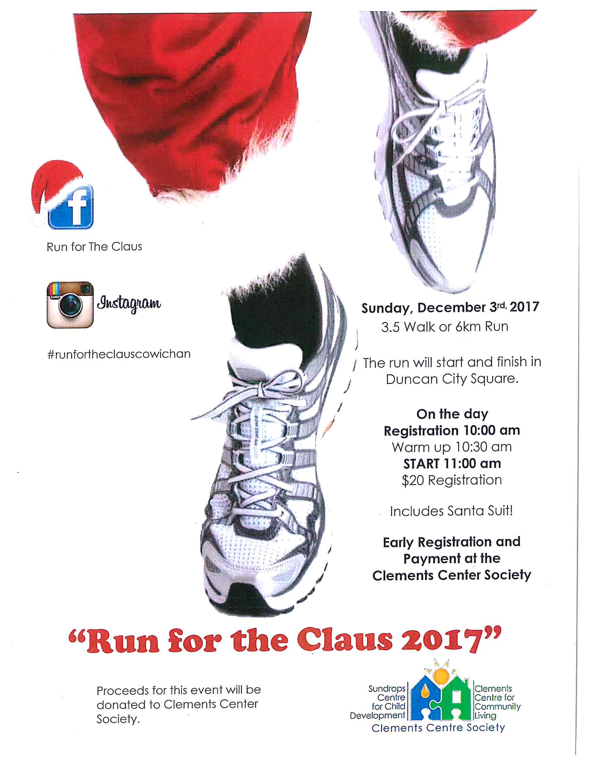

**C:\Program Files (x86)\Microsoft Office\MEDIA\OFFICE12\Lines\BD10358_.gif**

**Upcoming Webinar -Literacy and the Outdoor Classroom**

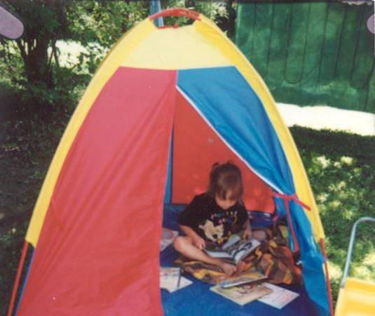Literacy is a developing communication system including oral skills, speaking, listening,

imagination, reading and writing.

In this webinar, we will explore the importance of the Outdoor Classroom and creative ways to bring literacy development to the play based environment.  We will relate the activities directly to the How Does Learning Happen? Document and discuss how to help parents understand how these literacy activities support the four foundations; Belonging, Engagement, Expression and Well-being.

Thursday, November 16, 2017

2:00 pm EST     11:00 am PST      7:00 pm EST    7:00 pm PST

Presented by Monica Carruthers

RECE, ECRT, AECEO.C

[www.ecedu.ca](http://shoutout.wix.com/so/9LzvUs7W/click?w=LS0tDQoyZjY2ZDljZC0xOTJlLTQ0ZDUtM2Y0Ny1iMTBhNmQwYzJjZmENCnd3dy5lY2VkdS5jYQ0KLS0t)

A recorded version of this webinar will be available on demand, by Nov. 30, 2017.

[More Information](http://shoutout.wix.com/so/9LzvUs7W/click?w=LS0tDQo4ZmRjOTJkNi1hNDA4LTRjMDktZmU0MC05ZTU2ZDBhNjE2NWENCmh0dHA6Ly93d3cuZWNlZHUuY2EvY29weS1vZi13ZWJpbmFycy0yMDE3DQotLS0)

**C:\Program Files (x86)\Microsoft Office\MEDIA\OFFICE12\Lines\BD10358_.gif**

Do you have a resource, event or information you would like to share?

Send it to [cindylisecchn@shaw.ca](mailto:cindylisecchn@shaw.ca) and it will be included in the weekly

**Health Matters Newsletter**