**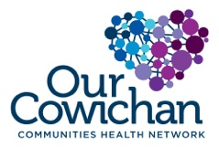**

**Health Matters Newsletter**

**November 17, 2017**

**Today’s Health Matters Includes:**

* Meeting Schedule
* Community Meetings and Events
* Data/ Research –
* Active 4 Life Summit
* Opioid Crisis and Dialogues
* Place Making Event
* Why Needle Exchanges and retractable needles are not effective
* Caleb Kroffat AED and CPR Training

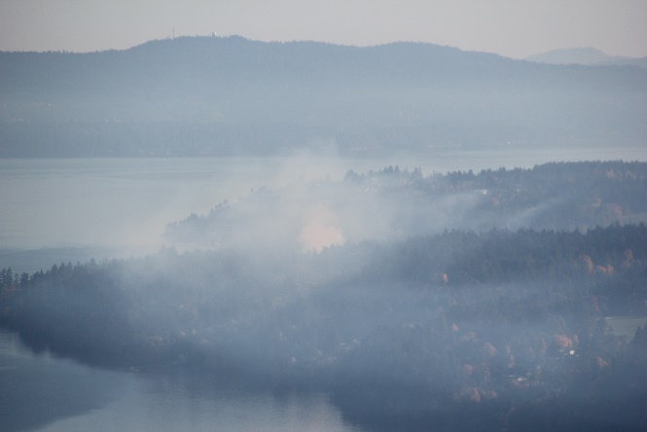

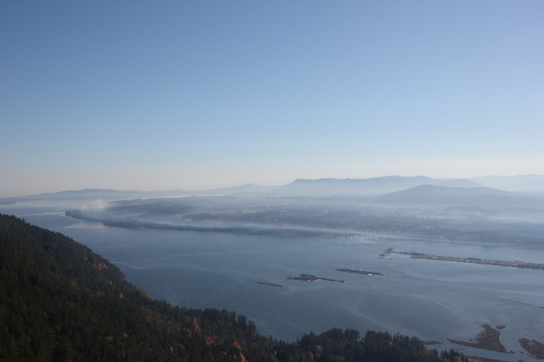

***The impact of open burning on the valley….. take a closer look!***

C:\Program Files (x86)\Microsoft Office\MEDIA\OFFICE12\Lines\BD10358_.gif

**Our Cowichan- Network Member Meetings-**

* **Next Admin Committee Meeting- December 7, 4:30-6:30** CVRD Committee Room 2
* **Next Our Cowichan Network Meeting** at **January 11 Ramada Silver Bridge**. Light dinner at 5:15 pm Meeting starts at 5:45 pm.

C:\Program Files (x86)\Microsoft Office\MEDIA\OFFICE12\Lines\BD10358_.gif

**Community Events- Meetings**

* **Community Response Team Meeting** December 21, 9 am-11amMeeting Room 213 at the CVRD
* **EPIC-Community Steering Committee** December 21, 1:30 -3:30 pm Ts’i’ts’uwatul’ Lelum

C:\Program Files (x86)\Microsoft Office\MEDIA\OFFICE12\Lines\BD10358_.gif

**Local Data and or Research-**

C:\Program Files (x86)\Microsoft Office\MEDIA\OFFICE12\Lines\BD10358_.gif

**Active 4 Life · A Physical Literacy Summit You won’t want to miss this!**

**November 24 | 6:30 pm - 9:15 pm and** **November 25 | 8:00 am - 2:00 pm**

**Island Savings Centre**

**Registration fee $25**

**Includes lunch on Saturday**

**What is Physical Literacy?**

The motivation, confidence, physical competence, knowledge and understanding to value and take responsibility for engagement in physical activities for life.

**Who is it for?**

These fun presentations are geared for parents, coaches, youth leaders, educators, health practitioners and recreation instructors working with children and youth.

**Why You’ll Want to Attend**

**·** Learn practical activities you can use in your programs and lessons

**·** Includes tips and tricks for enriching your physical and health services

**·** Gain strategies to reverse the trends around inactivity in our community

For Session Information, visit **www.cvrd.bc.ca**

To register, call or visit:

**Cowichan Lake Recreation** at **250.749.6742 - Island Savings Centre** at **250.748.7529**

**Kerry Park Recreation Centre** at **250.743.5922**

**C:\Program Files (x86)\Microsoft Office\MEDIA\OFFICE12\Lines\BD10358_.gif**

**Opioid Crisis and Dialogues**

This week we'd like to share two projects that recently "hit the news" and highlight the hard work and soft hearts of the people involved in organizing Opioid Dialogues in BC. (BTW: It has been such a joy for us to get to know so many people who care so much about the people in their community. Thank you to every one of you involved in this provincial project!)

One is a wonderful write-up featuring the Nelson Fentanyl Task Force (please see attached), which encourages us to think deeply about the way we tend to label people who use drugs. The other is a short video featuring the Port Alberni Shelter Society and a local story that encourages us to think outside the box when it comes to who we think is at risk of overdose: <https://m.youtube.com/watch?v=32k2bi0i8TI&feature=youtu.be>

In keeping with this theme of "news" and questioning how we tend to think and talk about people who use opioids, we're also attaching a recent article from Utne Reader about opioid use among Canadian seniors. <https://www.utne.com/mind-and-body/prescription-of-painkillers-zm0z17uzcwil>

**C:\Program Files (x86)\Microsoft Office\MEDIA\OFFICE12\Lines\BD10358_.gif**

**Save the Date: November 30, 6:30 p.m at the Cowichan Performing Arts Center**

**Youth Placemaking Cowichan Presentations!**

The next event in the Placemaking Vancouver Island Speaker Series is almost here and it’s not one to miss!

The CVRD and Social Planning Cowichan are excited to be hosting the **Youth Placemaking Cowichan Presentations!**

The Youth Placemaking project has engaged youth from local high schools to redesign public areas to create spaces that are inclusive, safe and resilient. Each group of students was supported by a teacher, an artist, and a planner to mentor the groups in bringing their visions to life over the last couple months. At this event the groups will now be presenting their final designs and judged by a panel of diverse local professionals.

This project empowers youth by giving them a voice in how public spaces are designed so that spaces can continue to develop with youth in mind ensuring that they welcome all members of the community.

Come support your local youth and learn about our communities from their perspective!

To register for this free event click on the link below!

[**http://www.cowichanpac.ca/event/youth-place-making-cowichan-design-charrette-competition**](http://www.cowichanpac.ca/event/youth-place-making-cowichan-design-charrette-competition)

***Please circulate this internally and to any friends or family members that may be interested!***

**C:\Program Files (x86)\Microsoft Office\MEDIA\OFFICE12\Lines\BD10358_.gif**

**Why Needle Exchanges and retractable needles are not effective**

Here is a document from the provincial harm reduction website that outline why needles exchanges and retractable needles aren’t best practices in relation to harm reduction: <http://towardtheheart.com/assets/uploads/14992759022IgdkJYAt7wHJgS77wACeYfPCHtIkjflA4cF26t.pdf>

**C:\Program Files (x86)\Microsoft Office\MEDIA\OFFICE12\Lines\BD10358_.gif**

Do you have a resource, event or information you would like to share?

Send it to [cindylisecchn@shaw.ca](mailto:cindylisecchn@shaw.ca) and it will be included in the weekly

**Health Matters Newsletter**