****

**Health Matters Newsletter**

**November 10, 2017**

**Today’s Health Matters Includes:**

* 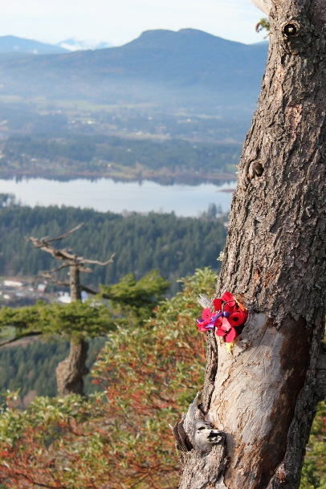Meeting Schedule
* Community Meetings and Events
* Data/ Research – History in our Cenotaph
* Active 4 Life Summit
* Homelessness from an Aboriginal Perspective
* Call for Alzheimer’s Walk Lead
* Place Making Event

*This was a photo from last year of some poppies overlooking our valley perched high on top of Mount Tzouhalem. Lest We Forget*

C:\Program Files (x86)\Microsoft Office\MEDIA\OFFICE12\Lines\BD10358_.gif

**Our Cowichan- Network Member Meetings-**

* **Next Admin Committee Meeting- December 7, 4:30-6:30** CVRD Committee Room 2
* **Next Our Cowichan Network Meeting** at **January 11 Ramada Silver Bridge**. Light dinner at 5:15 pm Meeting starts at 5:45 pm.

C:\Program Files (x86)\Microsoft Office\MEDIA\OFFICE12\Lines\BD10358_.gif

**Community Events- Meetings**

* **Community Response Team Meeting** November 16, 9 am-11amMeeting Room 213 at the CVRD
* **EPIC-Community Steering Committee** November 16, 1:30 -3:30 pm Ts’i’ts’uwatul’ Lelum

C:\Program Files (x86)\Microsoft Office\MEDIA\OFFICE12\Lines\BD10358_.gif

**Local Data and or Research-**Have you ever looked closely at the Duncan Cenotaph? If so, you’ll have noticed that, beside the obvious demarcation between the names listed for the First and Second World Wars, there are three further distinctions.

These are Killed, Missing in Action, and On Active Service.

Killed and missing are pretty straightforward. But what does it mean, On Active Service?

This is a catch-all category for those Canadian servicemen and service women who died in wartime but whose deaths may have resulted from accidents of any description and illness — not just in the frontlines and under fire, but while serving their nation wherever they were posted, at home and abroad. This includes nurses but not, regrettably, merchant mariners. (Another story for another time.)

In other words, they wouldn’t have been in that particular time and place within Canada or overseas when they became ill or were fatally injured but for the fact that they were there serving as members of the Canadian military or nursing corps — ergo, On Active Service.

So they, too, have earned their Remembrance and having their names on Duncan’s Cenotaph and those across Canada.

C:\Program Files (x86)\Microsoft Office\MEDIA\OFFICE12\Lines\BD10358_.gif

**Active 4 Life · A Physical Literacy Summit You won’t want to miss this!**

**November 24 | 6:30 pm - 9:15 pm and** **November 25 | 8:00 am - 2:00 pm**

**Island Savings Centre**

**Registration fee $25**

**Includes lunch on Saturday**

**What is Physical Literacy?**

The motivation, confidence, physical competence, knowledge and understanding to value and take responsibility for engagement in physical activities for life.

**Who is it for?**

These fun presentations are geared for parents, coaches, youth leaders, educators, health practitioners and recreation instructors working with children and youth.

**Why You’ll Want to Attend**

**·** Learn practical activities you can use in your programs and lessons

**·** Includes tips and tricks for enriching your physical and health services

**·** Gain strategies to reverse the trends around inactivity in our community

For Session Information, visit **www.cvrd.bc.ca**

To register, call or visit:

**Cowichan Lake Recreation** at **250.749.6742 - Island Savings Centre** at **250.748.7529**

**Kerry Park Recreation Centre** at **250.743.5922**

**C:\Program Files (x86)\Microsoft Office\MEDIA\OFFICE12\Lines\BD10358_.gif**

**Homelessness from and Aboriginal Perspective**

link to an article about an Aboriginal man who is redefining homelessness from an Aboriginal perspective.  His name is Jesse Thistle.  I understand he was a keynote speaker at the recent national conference on homelessness that took place last week. He also has a profile on the Homeless Hub site. Formerly homeless himself, Mr Thistle frames homelessness from an Aboriginal perspective as losing a sense of identity and connection to "All my Relations."

<http://www.cbc.ca/news/indigenous/jesse-thistle-indigenous-homelessness-1.4373735>

**C:\Program Files (x86)\Microsoft Office\MEDIA\OFFICE12\Lines\BD10358_.gif**

Do you have a resource, event or information you would like to share?

Send it to [cindylisecchn@shaw.ca](mailto:cindylisecchn@shaw.ca) and it will be included in the weekly

**Health Matters Newsletter**